**MongoDB Tutorial**

# MongoDB TutorialMongoDB Tutorial

MongoDB tutorial provides basic and advanced concepts of SQL. Our MongoDB tutorial is designed for beginners and professionals.

MongoDB is a No SQL database. It is an open-source, cross-platform, document-oriented database written in C++.

Our MongoDB tutorial includes all topics of MongoDB database such as insert documents, update documents, delete documents, query documents, projection, sort() and limit() methods, create a collection, drop collection, etc. There are also given MongoDB interview questions to help you better understand the MongoDB database.

## What is MongoDB

[MongoDB](https://www.javatpoint.com/mongodb-tutorial) is an open-source document database that provides high performance, high availability, and automatic scaling.

In simple words, you can say that - Mongo DB is a document-oriented database. It is an open source product, developed and supported by a company named 10gen.

MongoDB is available under General Public license for free, and it is also available under Commercial license from the manufacturer.

The manufacturing company 10gen has defined MongoDB as:

"MongoDB is a scalable, open source, high performance, document-oriented database." - 10gen

MongoDB was designed to work with commodity servers. Now it is used by the company of all sizes, across all industry.

## History of MongoDB

The initial development of MongoDB began in 2007 when the company was building a platform as a service similar to window azure.

Window azure is a cloud computing platform and infrastructure, created by Microsoft, to build, deploy and manage applications and service through a global network.

MongoDB was developed by a NewYork based organization named 10gen which is now known as MongoDB Inc. It was initially developed as a PAAS (Platform as a Service). Later in 2009, it is introduced in the market as an open source database server that was maintained and supported by MongoDB Inc.

The first ready production of MongoDB has been considered from version 1.4 which was released in March 2010.

MongoDB2.4.9 was the latest and stable version which was released on January 10, 2014.

## Purpose of Building MongoDB

It may be a very genuine question that - "what was the need of MongoDB although there were many databases in action?"

**There is a simple answer:**

All the modern applications require big data, fast features development, flexible deployment, and the older database systems not competent enough, so the MongoDB was needed.

**The primary purpose of building MongoDB is:**

* Scalability
* Performance
* High Availability
* Scaling from single server deployments to large, complex multi-site architectures.
* Key points of MongoDB
* Develop Faster
* Deploy Easier
* Scale Bigger

First of all, we should know what is document oriented database?

### Example of Document-Oriented Database

MongoDB is a document-oriented database. It is a key feature of MongoDB. It offers a document-oriented storage. It is very simple you can program it easily.

MongoDB stores data as documents, so it is known as document-oriented database.

1. FirstName = "John",
2. Address = "Detroit",
3. Spouse = [{**Name**: "Angela"}].
4. FirstName ="John",
5. Address = "Wick"

**There are two different documents (separated by ".").**

Storing data in this manner is called as document-oriented database.

Mongo DB falls into a class of databases that calls Document Oriented Databases. There is also a broad category of database known as [No SQL Databases](https://www.javatpoint.com/nosql-databases).

## Features of MongoDB

These are some important features of MongoDB:

**1. Support ad hoc queries**

In MongoDB, you can search by field, range query and it also supports regular expression searches.

**2. Indexing**

You can index any field in a document.

**3. Replication**

MongoDB supports Master Slave replication.

A master can perform Reads and Writes and a Slave copies data from the master and can only be used for reads or back up (not writes)

**4. Duplication of data**

MongoDB can run over multiple servers. The data is duplicated to keep the system up and also keep its running condition in case of hardware failure.

**5. Load balancing**

It has an automatic load balancing configuration because of data placed in shards.

**Provides high performance**.

* JSON data model with dynamic schemas
* Auto-sharding for horizontal scalability
* Built in replication for high availability
* Now a day many companies using MongoDB to create new types of applications, improve performance and availability.

## Prerequisite

Before learning MongoDB, you must have the basic knowledge of SQL and OOPs.

A MongoDB Document

Records in a MongoDB database are called documents, and the field values may include numbers, strings, booleans, arrays, or even nested documents.

Example Document

{

title: "Post Title 1",

body: "Body of post.",

category: "News",

likes: 1,

tags: ["news", "events"],

date: Date()

}

## How to set up the MongoDB environment

1. C:\Program Files\MongoDB\bin\mongod.exe

This will start the mongoDB database process. If you get a message "waiting for connection" in the console output, it indicates that the mongodb.exe process is running successfully.

**For example:**

When you connect to the MongoDB through the mongo.exe shell, you should follow these steps:

1. Open another command prompt.
2. At the time of connecting, specify the data directory if necessary.

#### **Note: If you use the default data directory while MongoDB installation, there is no need to specify the data directory.**

**For example:**

1. C:\mongodb\bin\mongo.exe

Install MongoDB Shell (mongosh)

There are many ways to connect to your MongoDB database.

We will start by using the MongoDB Shell, mongosh.

Use the [official instructions](https://docs.mongodb.com/mongodb-shell/install/?utm_campaign=w3schools_mdb&utm_source=w3schools&utm_medium=referral) to install mongosh on your operating system.

To verify that it has been installed properly, open your terminal and type:

mongosh --version

You should see that the latest verion is installed.

MongoDB supports many datatypes. Some of them are −

* **String** − This is the most commonly used datatype to store the data. String in MongoDB must be UTF-8 valid.
* **Integer** − This type is used to store a numerical value. Integer can be 32 bit or 64 bit depending upon your server.
* **Boolean** − This type is used to store a boolean (true/ false) value.
* **Double** − This type is used to store floating point values.
* **Min/ Max keys** − This type is used to compare a value against the lowest and highest BSON elements.
* **Arrays** − This type is used to store arrays or list or multiple values into one key.
* **Timestamp** − ctimestamp. This can be handy for recording when a document has been modified or added.
* **Object** − This datatype is used for embedded documents.
* **Null** − This type is used to store a Null value.
* **Symbol** − This datatype is used identically to a string; however, it's generally reserved for languages that use a specific symbol type.
* **Date**− This datatype is used to store the current date or time in UNIX time format. You can specify your own date time by creating object of Date and passing day, month, year into it.
* **Object ID** − This datatype is used to store the document’s ID.
* **Binary data** − This datatype is used to store binary data.
* **Code** − This datatype is used to store JavaScript code into the document.
* **Regular expression** − This datatype is used to store regular expression.
* MongoDB mongosh Create Collection
* Create Collection using mongosh
* There are 2 ways to create a collection.
* Method 1
* You can create a collection using the createCollection() database method.
* Example
* db.createCollection("posts")
* The createCollection() Method
* MongoDB **db.createCollection(name, options)** is used to create collection.
* Syntax
* Basic syntax of **createCollection()** command is as follows −
* db.createCollection(name, options)
* In the command, **name** is name of collection to be created. **Options** is a document and is used to specify configuration of collection.

|  |  |  |
| --- | --- | --- |
| **Parameter** | **Type** | **Description** |
| Name | String | Name of the collection to be created |
| Options | Document | (Optional) Specify options about memory size and indexing |

* Method 2
* You can also create a collection during the insert process.
* Example
* We are here assuming object is a valid JavaScript object containing post data:
* db.posts.insertOne(object)
* This will create the "posts" collection if it does not already exist.
* **Remember:** In MongoDB, a collection is not actually created until it gets content!
* MongoDB mongosh Insert
* Insert Documents
* There are 2 methods to insert documents into a MongoDB database.
* insertOne()
* To insert a single document, use the insertOne() method.
* This method inserts a single object into the database.
* **Note:** When typing in the shell, after opening an object with curly braces "{" you can press enter to start a new line in the editor without executing the command. The command will execute when you press enter after closing the braces.
* Example
* db.posts.insertOne({
* title: "Post Title 1",
* body: "Body of post.",
* category: "News",
* likes: 1,
* tags: ["news", "events"],
* date: Date()
* })
* **Note:** If you try to insert documents into a collection that does not exist, MongoDB will create the collection automatically.
* insertMany()
* To insert multiple documents at once, use the insertMany() method.
* This method inserts an array of objects into the database.
* Example
* db.posts.insertMany([
* {
* title: "Post Title 2",
* body: "Body of post.",
* category: "Event",
* likes: 2,
* tags: ["news", "events"],
* date: Date()
* },
* {
* title: "Post Title 3",
* body: "Body of post.",
* category: "Technology",
* likes: 3,
* tags: ["news", "events"],
* date: Date()
* },
* {
* title: "Post Title 4",
* body: "Body of post.",
* category: "Event",
* likes: 4,
* tags: ["news", "events"],
* date: Date()
* }
* ])

## The dropDatabase() Method

MongoDB **db.dropDatabase()** command is used to drop a existing database.

### Syntax

Basic syntax of **dropDatabase()** command is as follows −

db.dropDatabase()

This will delete the selected database. If you have not selected any database, then it will delete default 'test' database.

### Example

First, check the list of available databases by using the command, **show dbs**.

>show dbs

local 0.78125GB

mydb 0.23012GB

test 0.23012GB

>

If you want to delete new database **<mydb>**, then **dropDatabase()** command would be as follows −

>use mydb

switched to db mydb

>db.dropDatabase()

>{ "dropped" : "mydb", "ok" : 1 }

>

Now check list of databases.

>show dbs

local 0.78125GB

test 0.23012GB

>

MongoDB mongosh Find

Find Data

There are 2 methods to find and select data from a MongoDB collection, find() and findOne().

find()

To select data from a collection in MongoDB, we can use the find() method.

This method accepts a query object. If left empty, all documents will be returned.

Example

db.posts.find()

findOne()

To select only one document, we can use the findOne() method.

This method accepts a query object. If left empty, it will return the first document it finds.

**Note:** This method only returns the first match it finds.

Example

db.posts.findOne()

Querying Data

To query, or filter, data we can include a query in our find() or findOne() methods.

Example

db.posts.find( {category: "News"} )

Projection

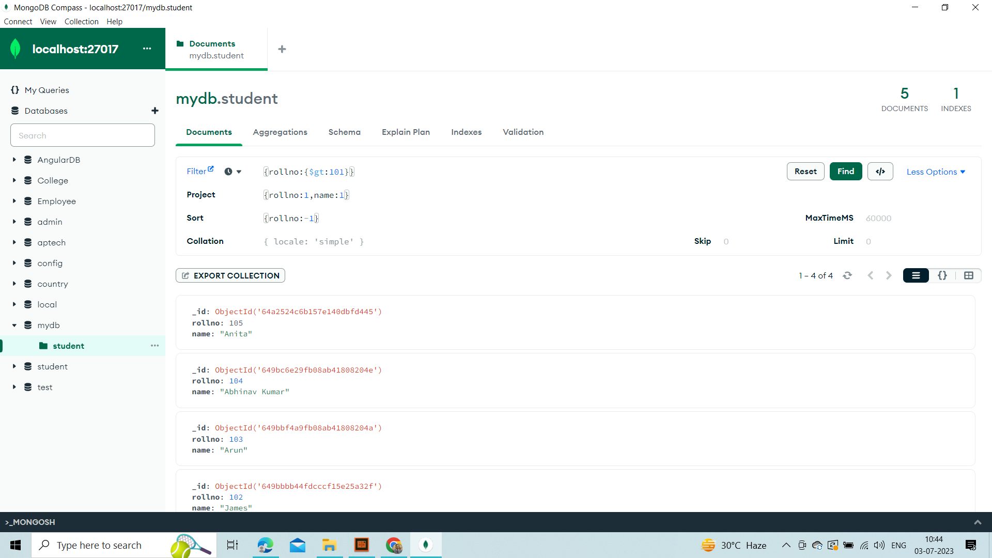

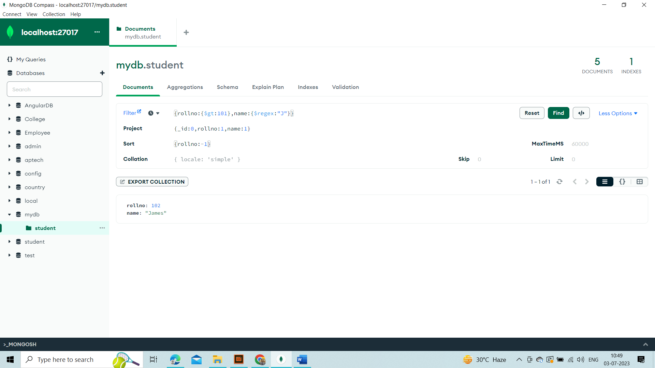

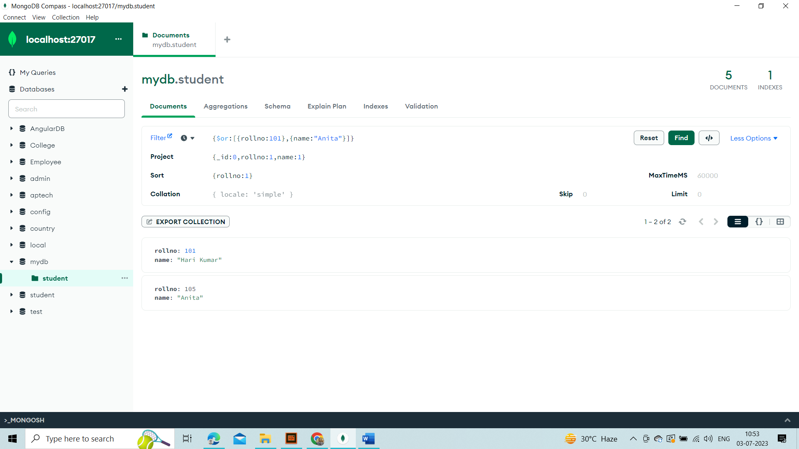

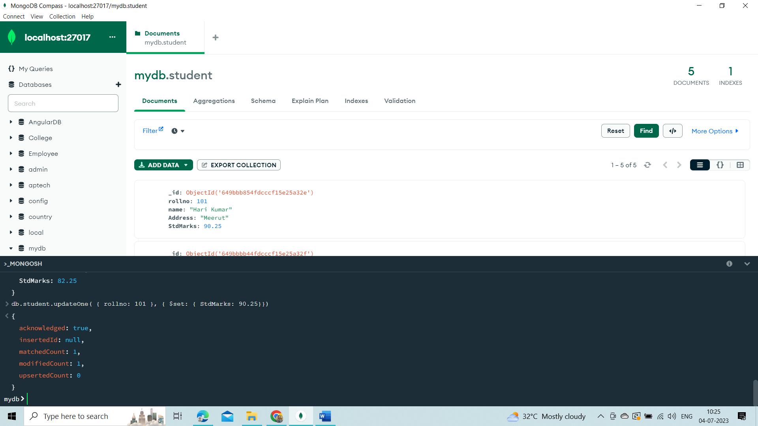

Both find methods accept a second parameter called projection.

This parameter is an object that describes which fields to include in the results.

**Note:** This parameter is optional. If omitted, all fields will be included in the results.

Example

This example will only display the title and date fields in the results.

db.posts.find({}, {title: 1, date: 1})

Notice that the _id field is also included. This field is always included unless specifically excluded.

We use a 1 to include a field and 0 to exclude a field.

Example

This time, let's exclude the _id field.

db.posts.find({}, {_id: 0, title: 1, date: 1})

**Note:** You cannot use both 0 and 1 in the same object. The only exception is the _id field. You should either specify the fields you would like to include or the fields you would like to exclude.

Let's exclude the date category field. All other fields will be included in the results.

Example

db.posts.find({}, {category: 0})

We will get an error if we try to specify both 0 and 1 in the same object.

Example

db.posts.find({}, {title: 1, date: 0})

**Search Query**

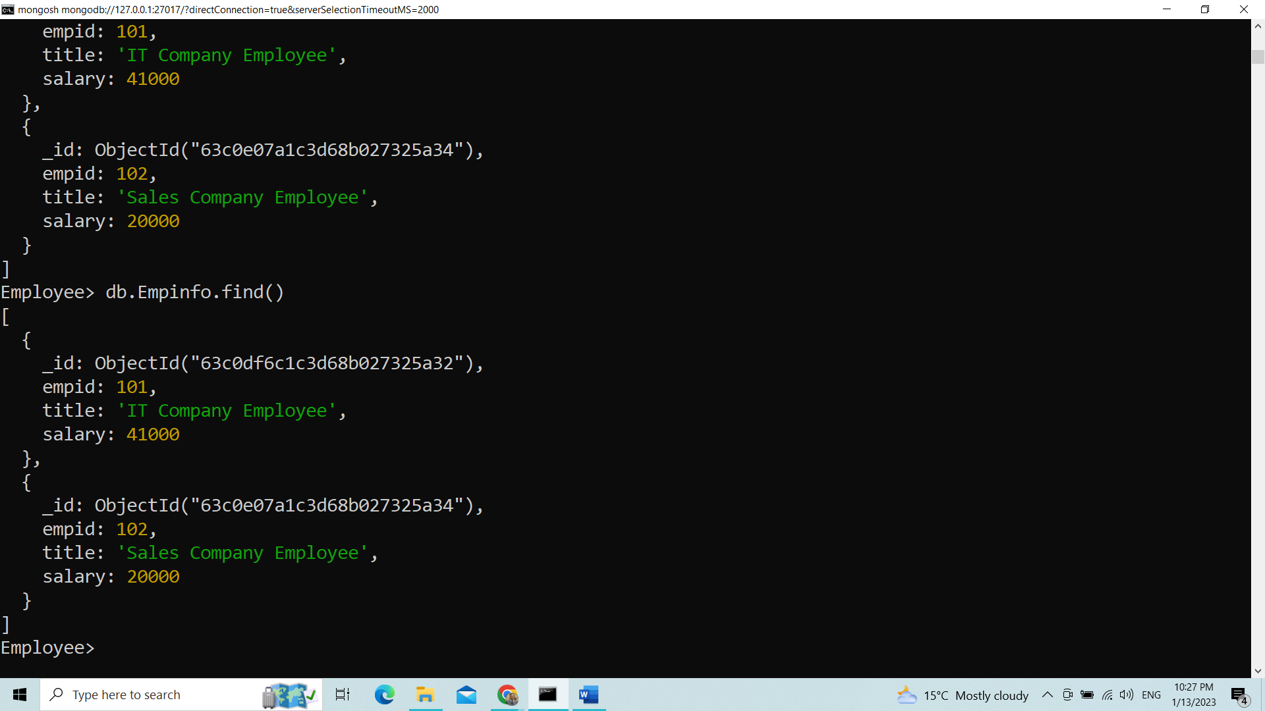

Search db.getCollection(‘Empinfo’).find({})

Search db.getCollection(‘Empinfo’).find({},{empid:1,salary:1})

Search db.getCollection(‘Empinfo’).find({},{empid:1,salary:1,_id:0})

Zero means expect given field name

Search db.getCollection(‘Empinfo’).find({},{empid:0,salary:0})

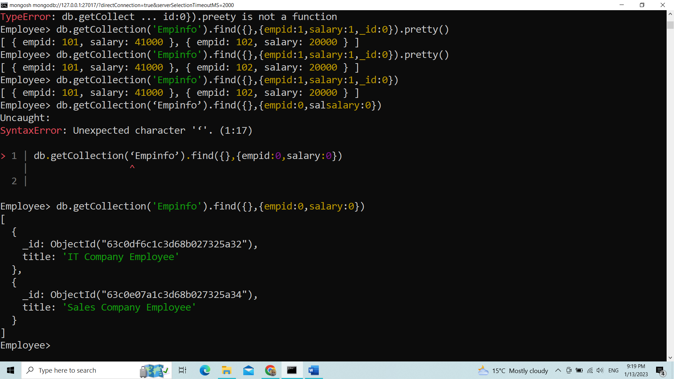

db.getCollection(‘Empinfo’).findOne({},{empid:1,salary:1})

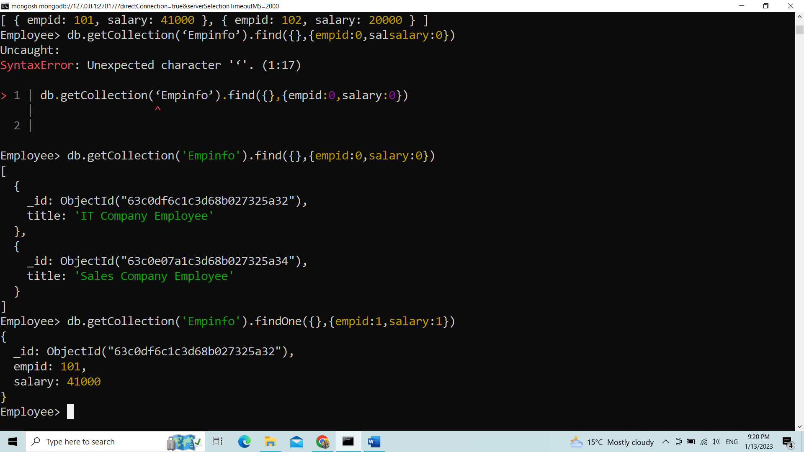

Use 1- true, o- False for sorting in ascending

Logical Condition operator

db.getCollection(‘Empinfo’).find({salary:{$lt:10000}});

Regular expression

db.getCollection(‘Empinfo’).find({name:{$regex:”p”}});

Logical Condition

db.getCollection(‘Empinfo’).find({$and:[{empid:101},{salary:20000}]});

db.getCollection(‘Empinfo’).find({$or:[{empid:101},{salary:20000}]});

salary:0 use for salary hide

db.getCollection(‘Empinfo’).find({},{salary:0}]});

MongoDB mongosh Update

Update Document

To update an existing document we can use the updateOne() or updateMany() methods.

The first parameter is a query object to define which document or documents should be updated.

The second parameter is an object defining the updated data.

updateOne()

The updateOne() method will update the first document that is found matching the provided query.

Let's see what the "like" count for the post with the title of "Post Title 1":

Example

db.posts.find( { title: "Post Title 1" } )

Now let's update the "likes" on this post to 2. To do this, we need to use the $set operator.

Example

db.posts.updateOne( { title: "Post Title 1" }, { $set: { likes: 2 } } )

Check the document again and you'll see that the "like" have been updated.

Example

db.posts.find( { title: "Post Title 1" } )

Insert if not found

If you would like to insert the document if it is not found, you can use the upsert option.

Example

Update the document, but if not found insert it:

db.posts.updateOne(

{ title: "Post Title 5" },

{

$set:

{

title: "Post Title 5",

body: "Body of post.",

category: "Event",

likes: 5,

tags: ["news", "events"],

date: Date()

}

},

{ upsert: true }

)

updateMany()

The updateMany() method will update all documents that match the provided query.

Example

Update likes on all documents by 1. For this we will use the $inc (increment) operator:

db.posts.updateMany({}, { $inc: { likes: 1 } })

MongoDB mongosh Delete

Delete Documents

We can delete documents by using the methods deleteOne() or deleteMany().

These methods accept a query object. The matching documents will be deleted.

deleteOne()

The deleteOne() method will delete the first document that matches the query provided.

Example

db.posts.deleteOne({ title: "Post Title 5" })

deleteMany()

The deleteMany() method will delete all documents that match the query provided.

Example

db.posts.deleteMany({ category: "Technology" })

## The drop() Method

MongoDB's **db.collection.drop()** is used to drop a collection from the database.

### Syntax

Basic syntax of **drop()** command is as follows −

db.COLLECTION_NAME.drop()

### Example

First, check the available collections into your database **mydb**.

>use mydb

switched to db mydb

>show collections

mycol

mycollection

system.indexes

tutorialspoint

>

Now drop the collection with the name **mycollection**.

>db.mycollection.drop()

true

>

Again check the list of collections into database.

>show collections

mycol

system.indexes

tutorialspoint

>

The pretty() Method

To display the results in a formatted way, you can use pretty() method.

Syntax

>db.COLLECTION_NAME.find().pretty()

RDBMS Where Clause Equivalents in MongoDB

To query the document on the basis of some condition, you can use following operations.

|  |  |  |  |
| --- | --- | --- | --- |
| **Operation** | **Syntax** | **Example** | **RDBMS Equivalent** |
| Equality | {<key>:{$eg;<value>}} | db.mycol.find({"by":"tutorials point"}).pretty() | where by = 'tutorials point' |
| Less Than | {<key>:{$lt:<value>}} | db.mycol.find({"likes":{$lt:50}}).pretty() | where likes < 50 |
| Less Than Equals | {<key>:{$lte:<value>}} | db.mycol.find({"likes":{$lte:50}}).pretty() | where likes <= 50 |
| Greater Than | {<key>:{$gt:<value>}} | db.mycol.find({"likes":{$gt:50}}).pretty() | where likes > 50 |
| Greater Than Equals | {<key>:{$gte:<value>}} | db.mycol.find({"likes":{$gte:50}}).pretty() | where likes >= 50 |
| Not Equals | {<key>:{$ne:<value>}} | db.mycol.find({"likes":{$ne:50}}).pretty() | where likes != 50 |
| Values in an array | {<key>:{$in:[<value1>, <value2>,……<valueN>]}} | db.mycol.find({"name":{$in:["Raj", "Ram", "Raghu"]}}).pretty() | Where name matches any of the value in :["Raj", "Ram", "Raghu"] |
| Values not in an array | {<key>:{$nin:<value>}} | db.mycol.find({"name":{$nin:["Ramu", "Raghav"]}}).pretty() | Where name values is not in the array :["Ramu", "Raghav"] or, doesn’t exist at all |

MongoDB Query Operators

MongoDB Query Operators

There are many query operators that can be used to compare and reference document fields.

Comparison

The following operators can be used in queries to compare values:

* $eq: Values are equal
* $ne: Values are not equal
* $gt: Value is greater than another value
* $gte: Value is greater than or equal to another value
* $lt: Value is less than another value
* $lte: Value is less than or equal to another value
* $in: Value is matched within an array

Logical

The following operators can logically compare multiple queries.

* $and: Returns documents where both queries match
* $or: Returns documents where either query matches
* $nor: Returns documents where both queries fail to match
* $not: Returns documents where the query does not match

Evaluation

The following operators assist in evaluating documents.

* $regex: Allows the use of regular expressions when evaluating field values
* $text: Performs a text search
* $where: Uses a JavaScript expression to match documents

MongoDB Update Operators

MongoDB Update Operators

There are many update operators that can be used during document updates.

Fields

The following operators can be used to update fields:

* $currentDate: Sets the field value to the current date
* $inc: Increments the field value
* $rename: Renames the field
* $set: Sets the value of a field
* $unset: Removes the field from the document

Array

The following operators assist with updating arrays.

* $addToSet: Adds distinct elements to an array
* $pop: Removes the first or last element of an array
* $pull: Removes all elements from an array that match the query
* $push: Adds an element to an array
* MongoDB Aggregation Pipelines
* Aggregation Pipelines
* Aggregation operations allow you to group, sort, perform calculations, analyze data, and much more.
* Aggregation pipelines can have one or more "stages". The order of these stages are important. Each stage acts upon the results of the previous stage.
* Example
* db.posts.aggregate([
* // Stage 1: Only find documents that have more than 1 like
* {
* $match: { likes: { $gt: 1 } }
* },
* // Stage 2: Group documents by category and sum each categories likes
* {
* $group: { _id: "$category", totalLikes: { $sum: "$likes" } }
* }
* ])

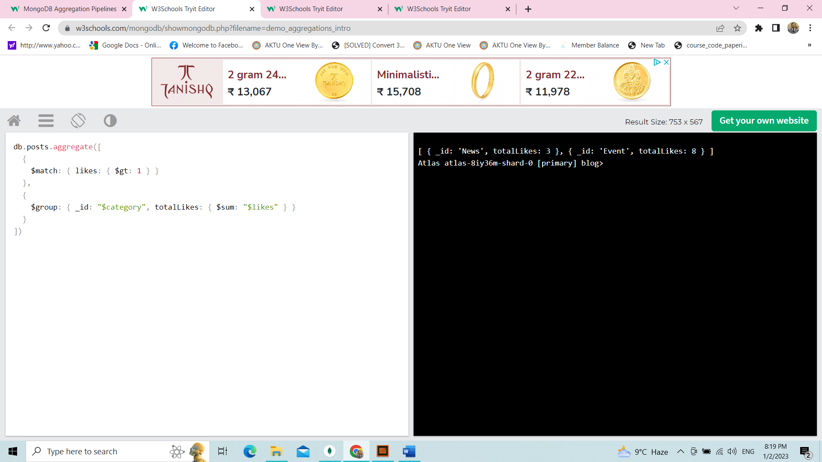

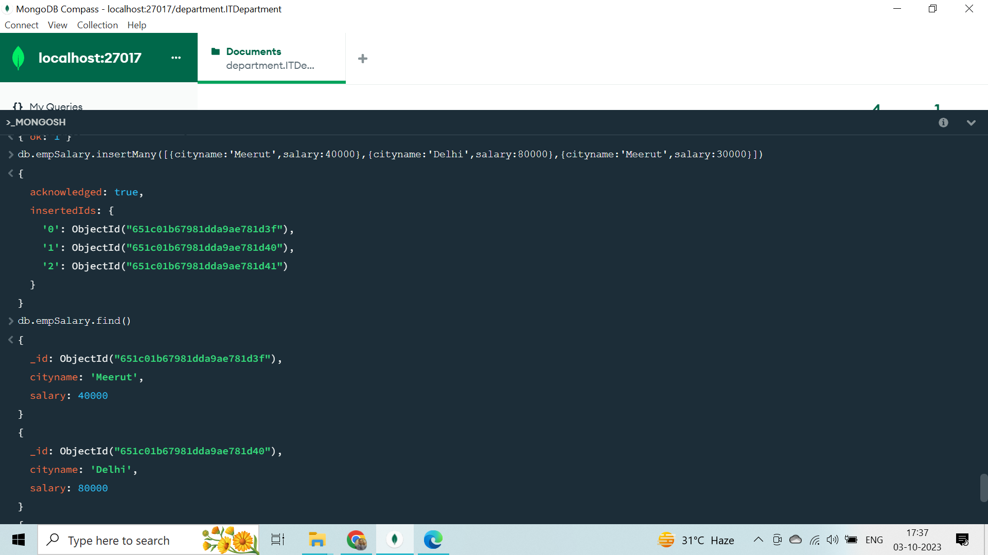

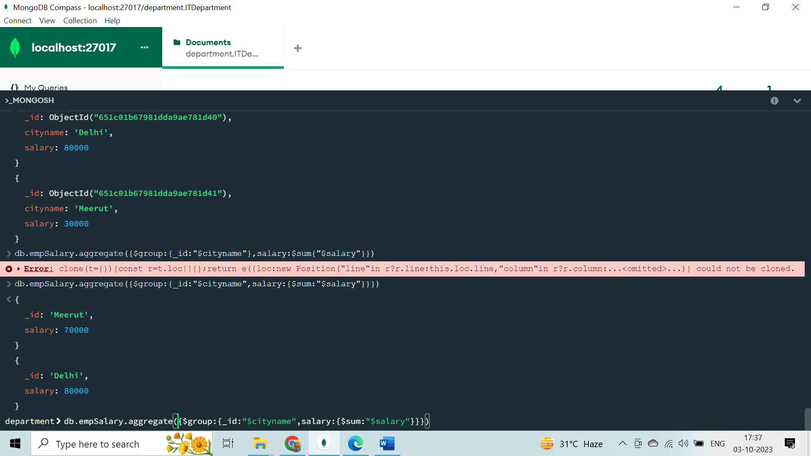

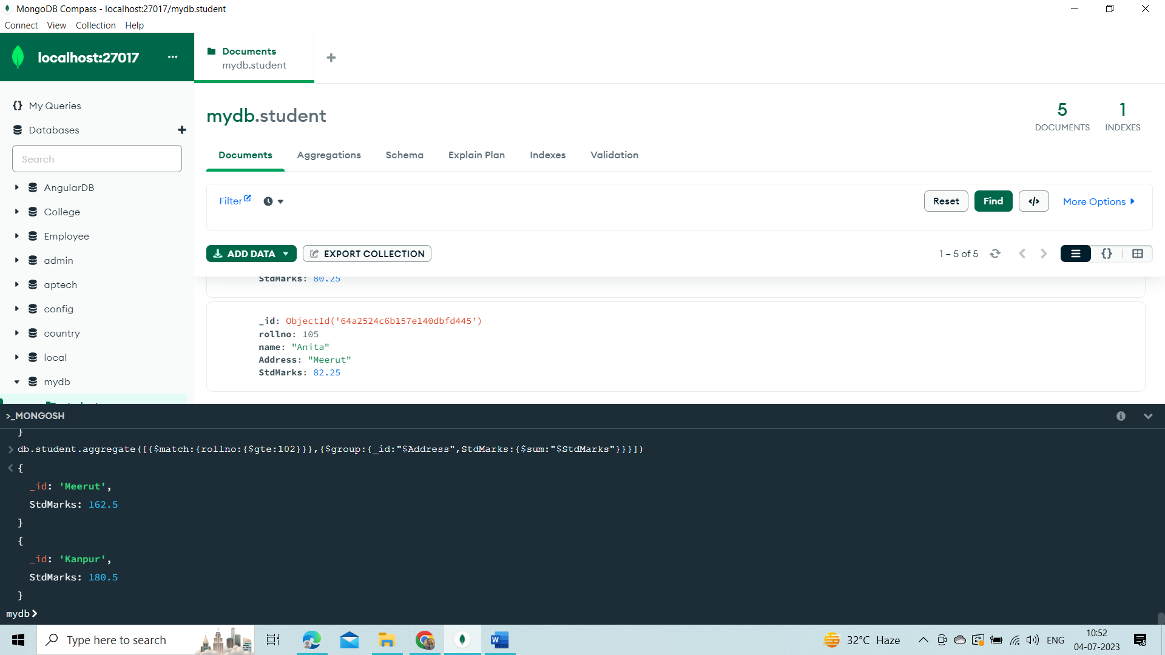

Sorting with Aggregate

db.student.aggregate([{$sort:{rollno:-1}}])

Sorting with Sort Function

db.student.find({}).sort({rollno:-1})

**Count with sum**

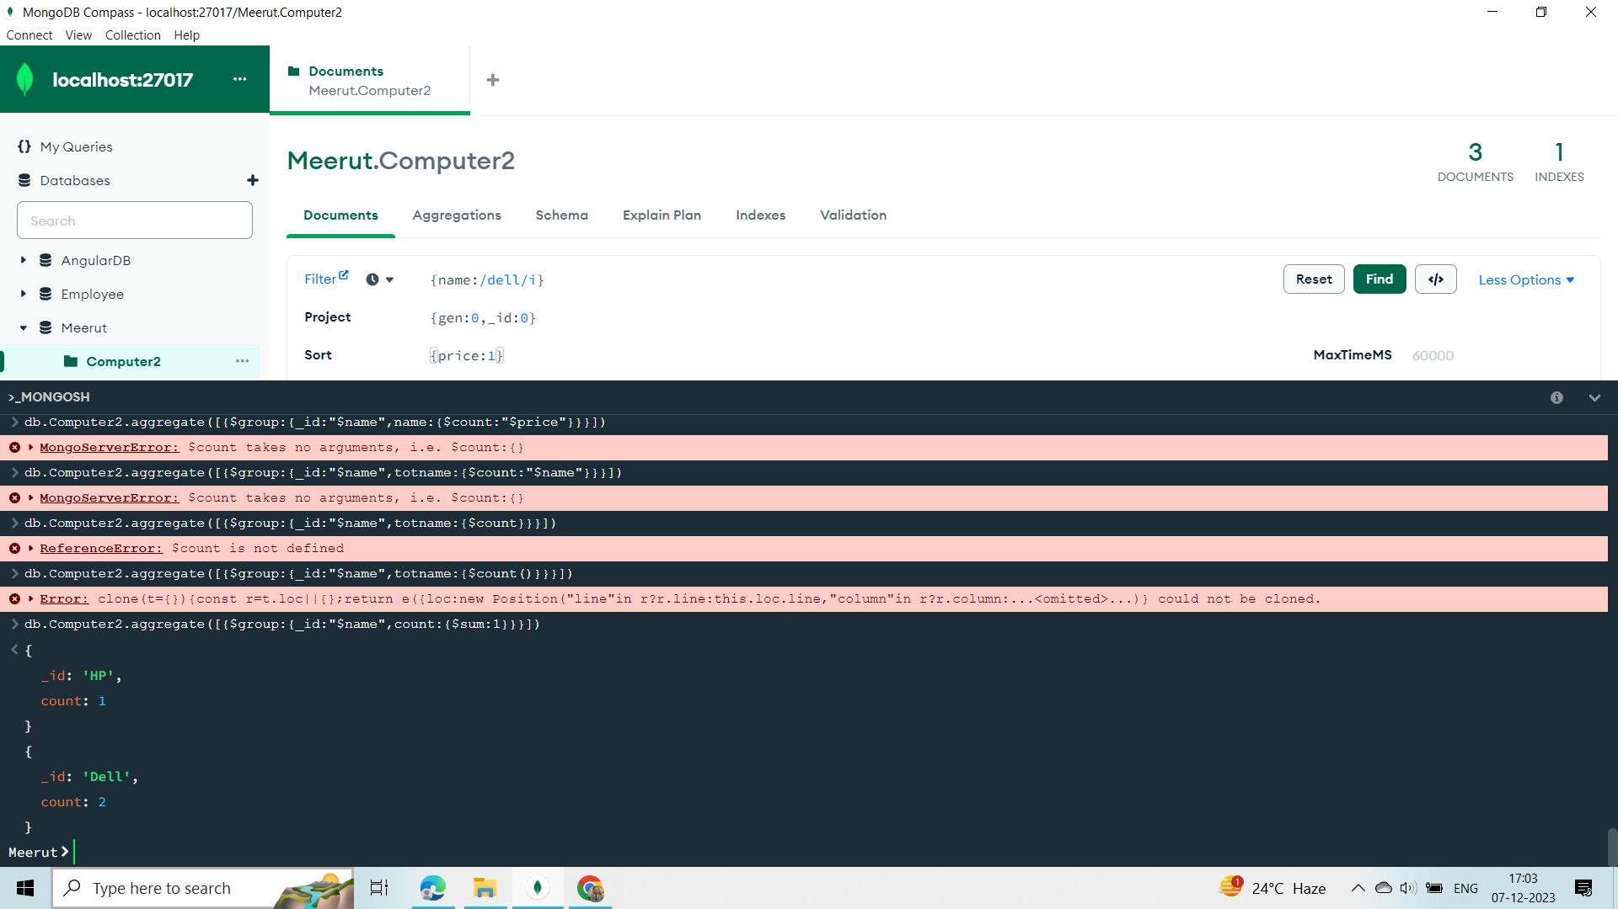

* Sample Data
* To demonstrate the use of stages in a aggregation pipeline, we will load sample data into our database.
* From the MongoDB Atlas dashboard, go to Databases. Click the ellipsis and select "Load Sample Dataset". This will load several sample datasets into your database.
* In the next sections we will explore several aggregation pipeline stages in more detail using this sample data.

**Aggregate with Project with $lt**

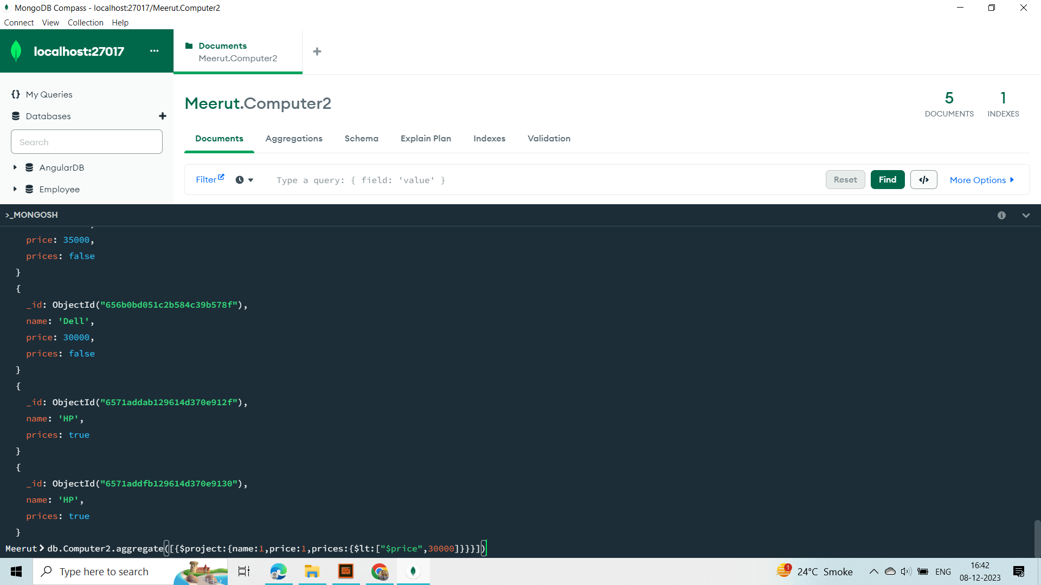

# MongoDB Aggregation $group

## Aggregation $group

This aggregation stage groups documents by the unique _id expression provided.

Don't confuse this _id expression with the _id ObjectId provided to each document.

### Example

In this example, we are using the "sample_airbnb" database loaded from our sample data in the [Intro to Aggregations](https://www.w3schools.com/mongodb/mongodb_aggregations_intro.php) section.

db.listingsAndReviews.aggregate(

[ { $group : { _id : "$property_type" } } ]

)

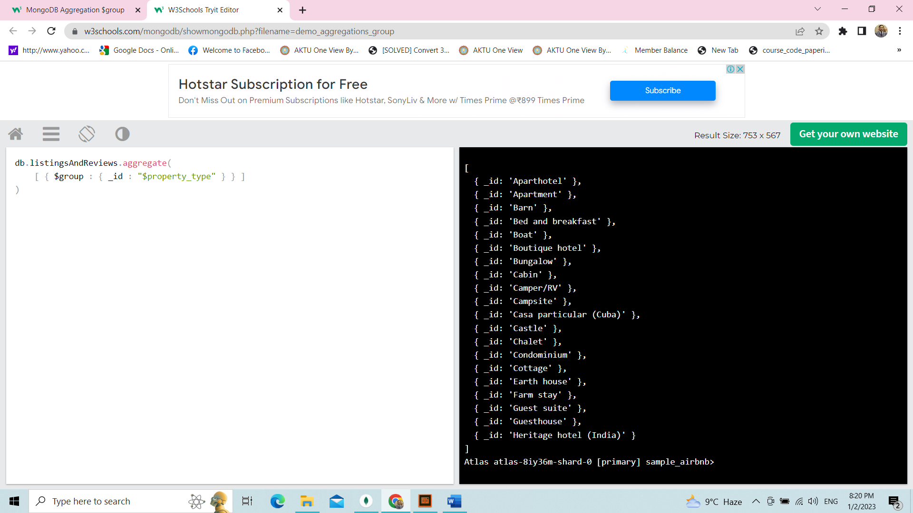

This will return the distinct values from the property_type field.

# MongoDB Aggregation $limit

## Aggregation $limit

This aggregation stage limits the number of documents passed to the next stage.

### Example

In this example, we are using the "sample_mflix" database loaded from our sample data in the [Intro to Aggregations](https://www.w3schools.com/mongodb/mongodb_aggregations_intro.php) section.

db.movies.aggregate([ { $limit: 1 } ])

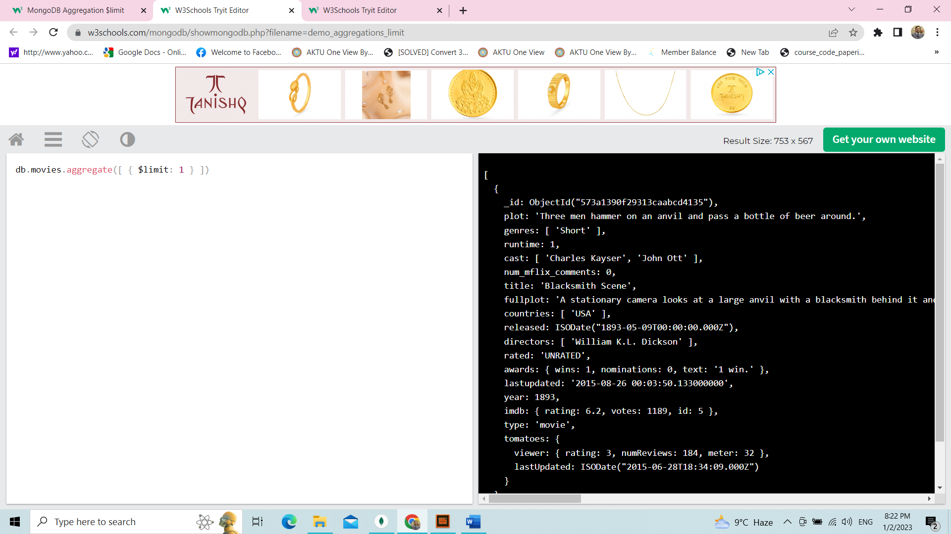

**Limit show only 1st Record**

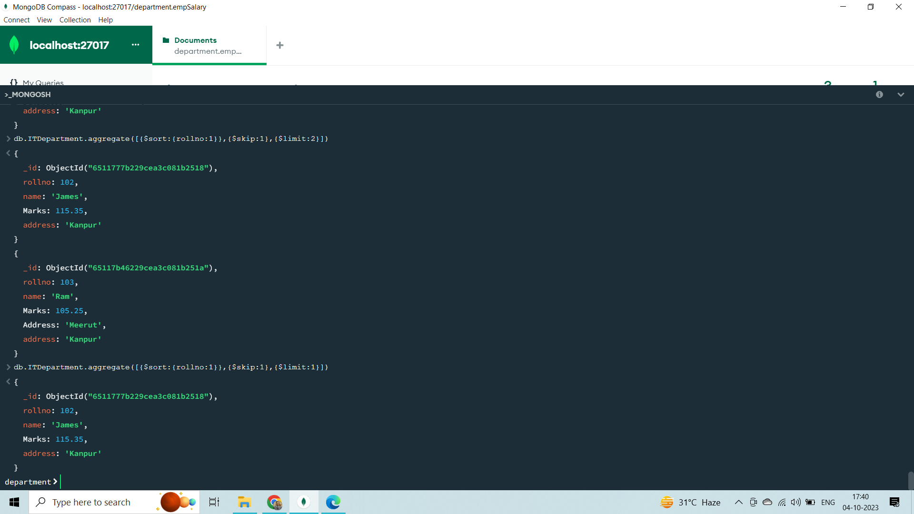

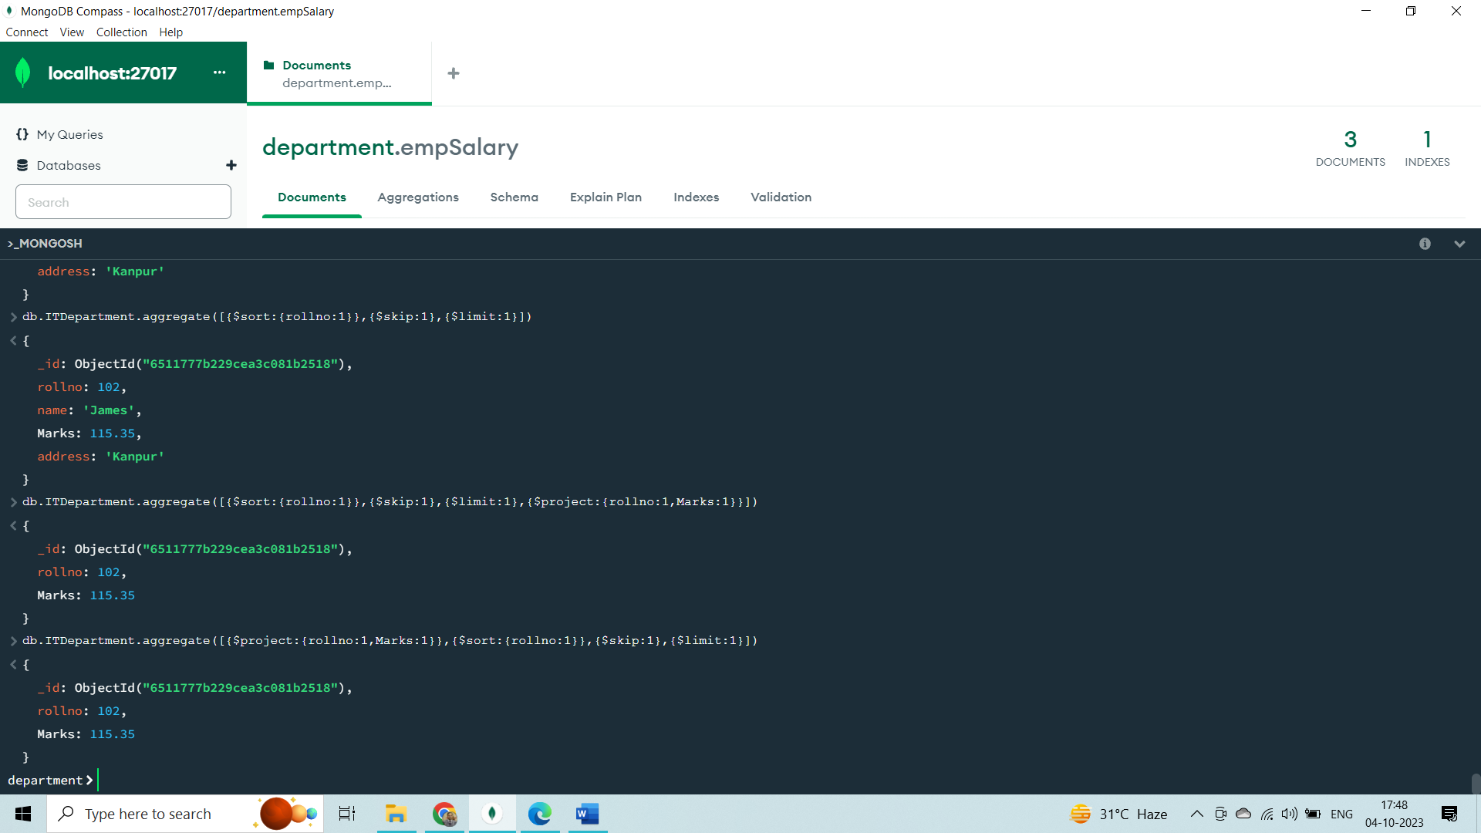

**With group**

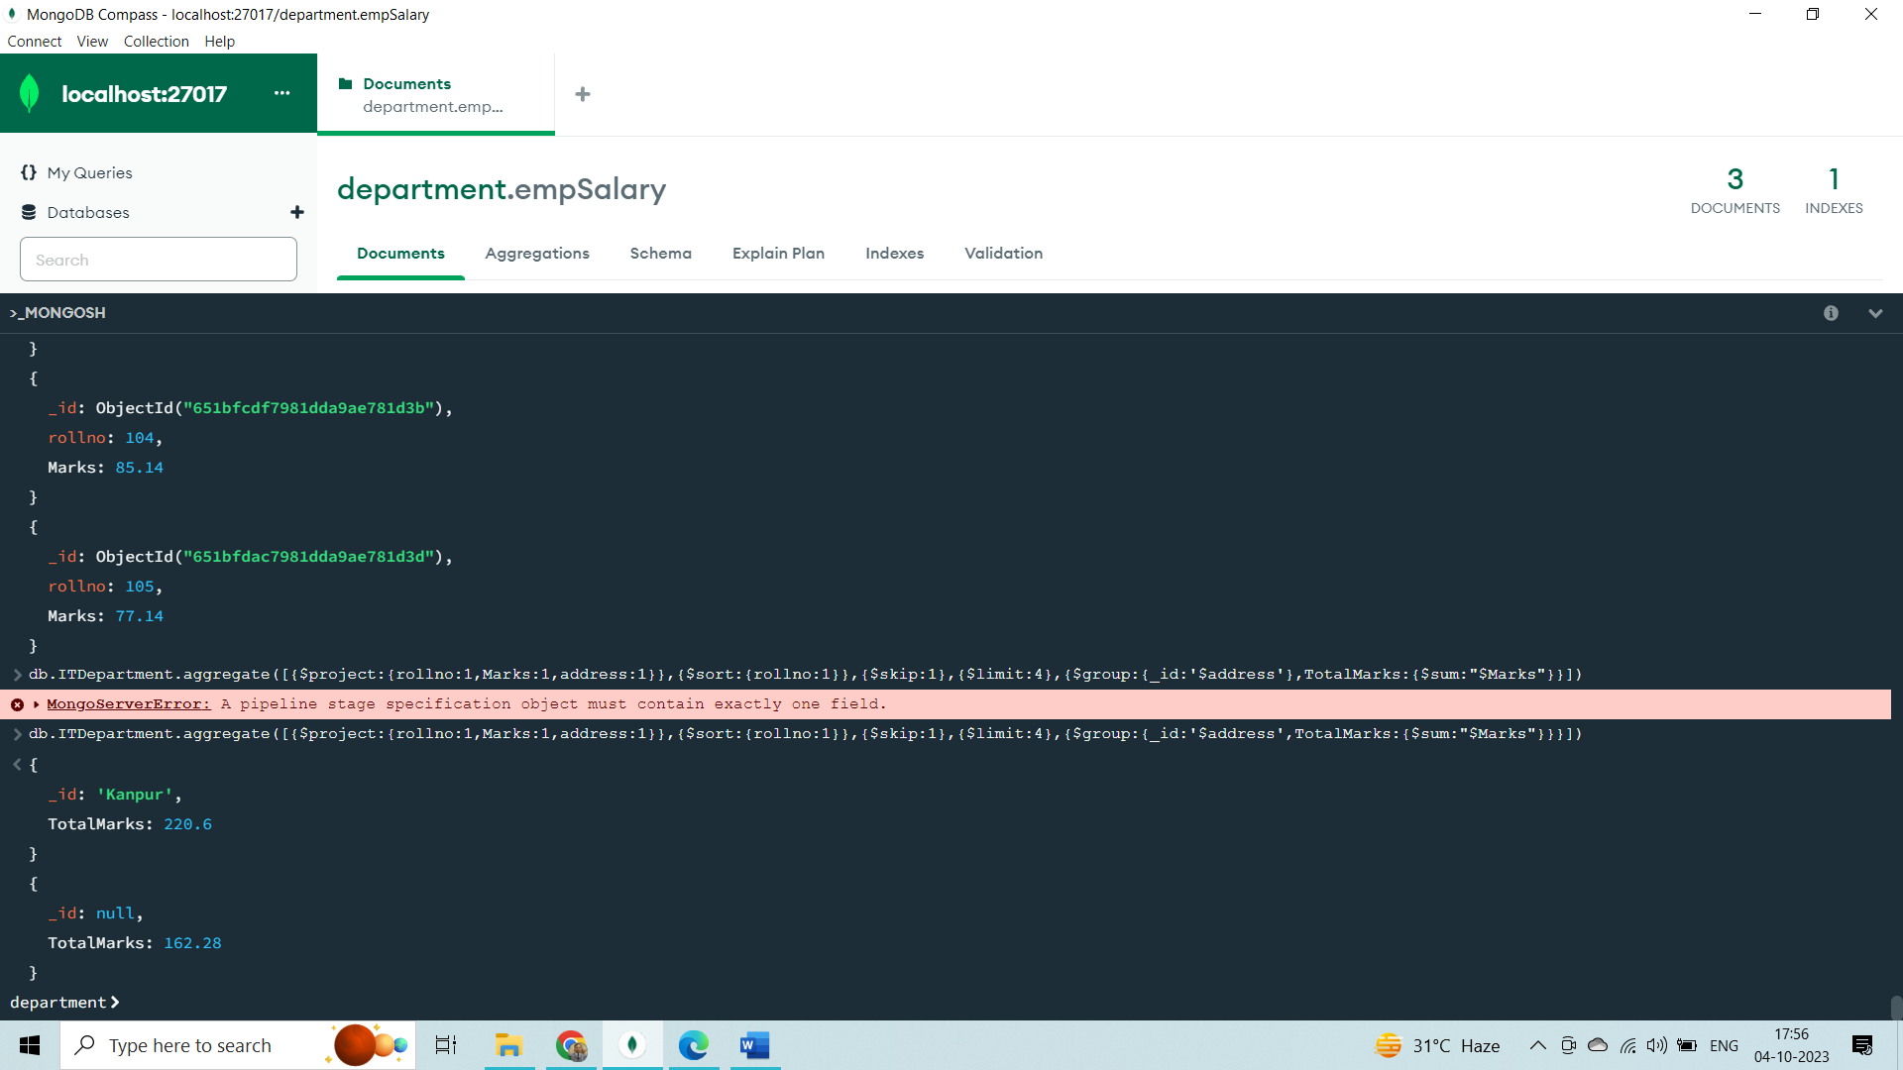

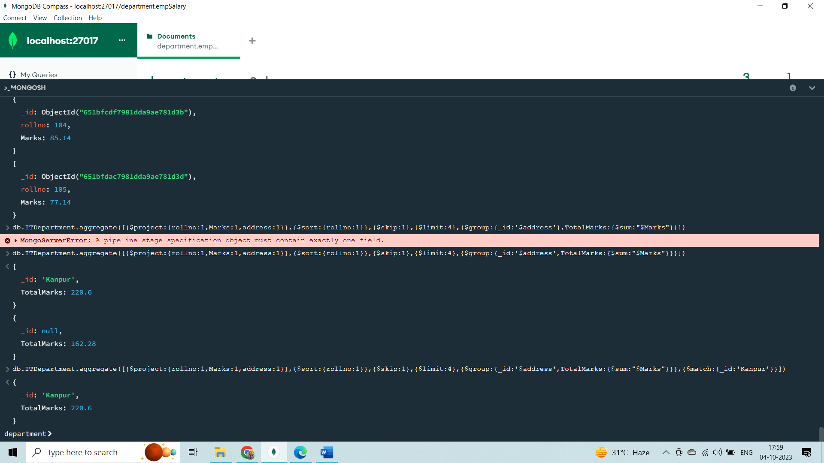

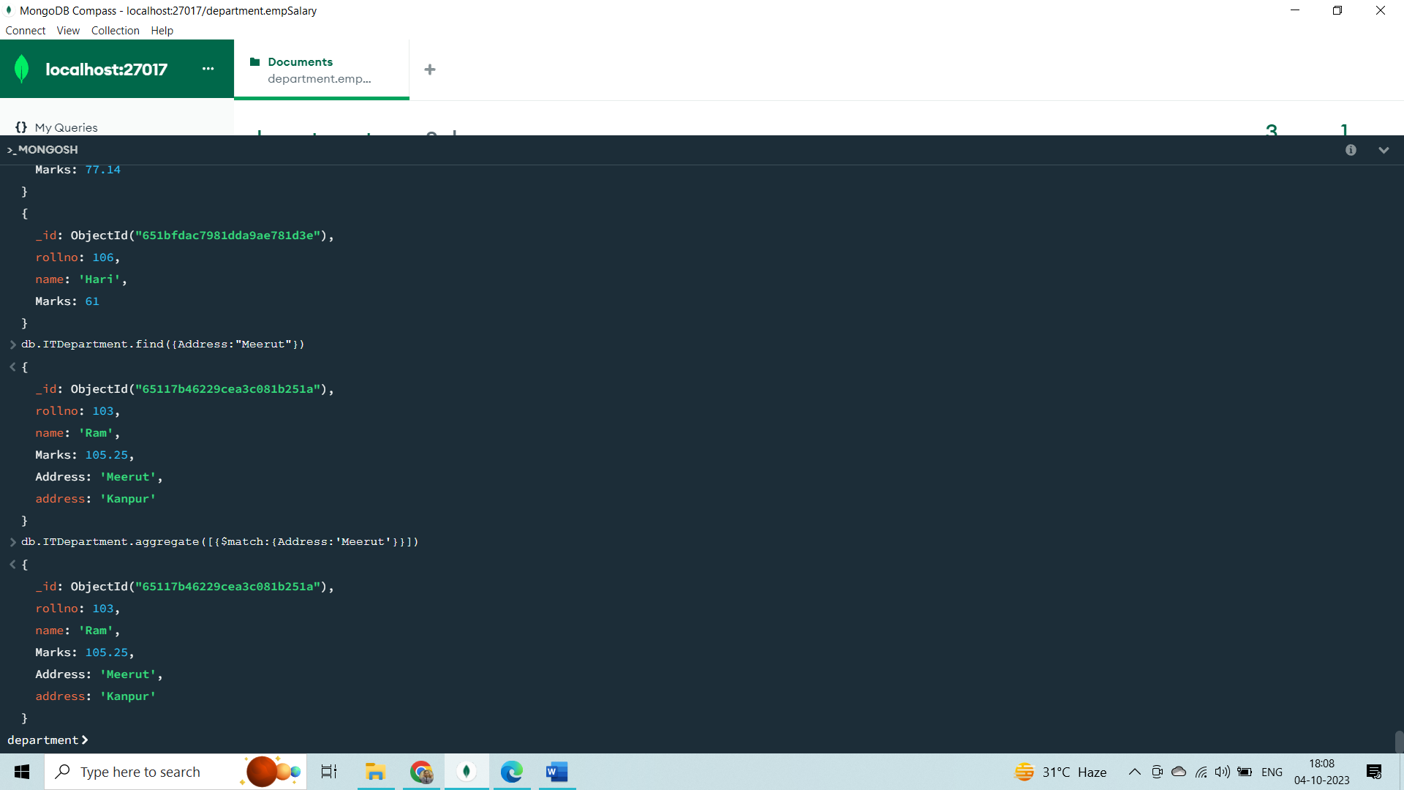

# MongoDB Aggregation $project

## Aggregation $project

This aggregation stage passes only the specified fields along to the next aggregation stage.

This is the same projection that is used with the find() method.

### Example

In this example, we are using the "sample_restaurants" database loaded from our sample data in the [Intro to Aggregations](https://www.w3schools.com/mongodb/mongodb_aggregations_intro.php) section.

db.restaurants.aggregate([

{

$project: {

"name": 1,

"cuisine": 1,

"address": 1

}

},

{

$limit: 5

}

])

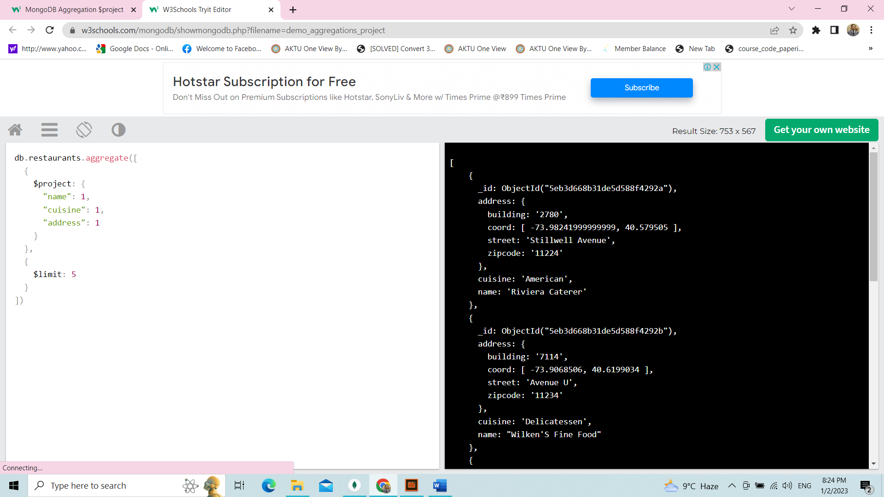

This will return the documents but only include the specified fields.

Notice that the _id field is also included. This field is always included unless specifically excluded.

We use a 1 to include a field and 0 to exclude a field.

**Note:** You cannot use both 0 and 1 in the same object. The only exception is the _id field. You should either specify the fields you would like to include or the fields you would like to exclude.

# MongoDB Aggregation $sort

## Aggregation $sort

This aggregation stage groups sorts all documents in the specified sort order.

Remember that the order of your stages matters. Each stage only acts upon the documents that previous stages provide.

### Example

In this example, we are using the "sample_airbnb" database loaded from our sample data in the [Intro to Aggregations](https://www.w3schools.com/mongodb/mongodb_aggregations_intro.php) section.

db.listingsAndReviews.aggregate([

{

$sort: { "accommodates": -1 }

},

{

$project: {

"name": 1,

"accommodates": 1

}

},

{

$limit: 5

}

])

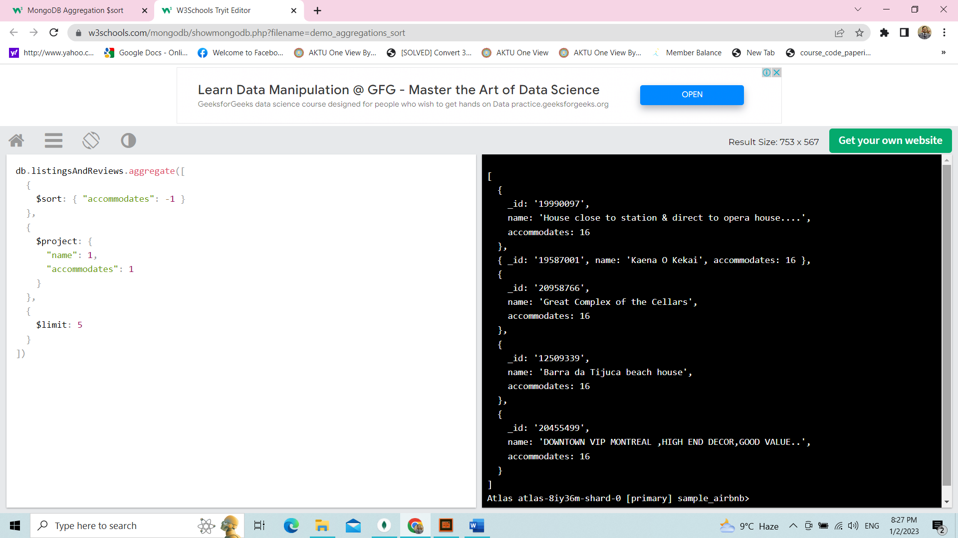

This will return the documents sorted in descending order by the accommodates field.

The sort order can be chosen by using 1 or -1. 1 is ascending and -1 is descending.

# MongoDB Aggregation $match

## Aggregation $match

This aggregation stage behaves like a find. It will filter documents that match the query provided.

Using $match early in the pipeline can improve performance since it limits the number of documents the next stages must process.

### Example

In this example, we are using the "sample_airbnb" database loaded from our sample data in the [Intro to Aggregations](https://www.w3schools.com/mongodb/mongodb_aggregations_intro.php) section.

db.listingsAndReviews.aggregate([

{ $match : { property_type : "House" } },

{ $limit: 2 },

{ $project: {

"name": 1,

"bedrooms": 1,

"price": 1

}}

])

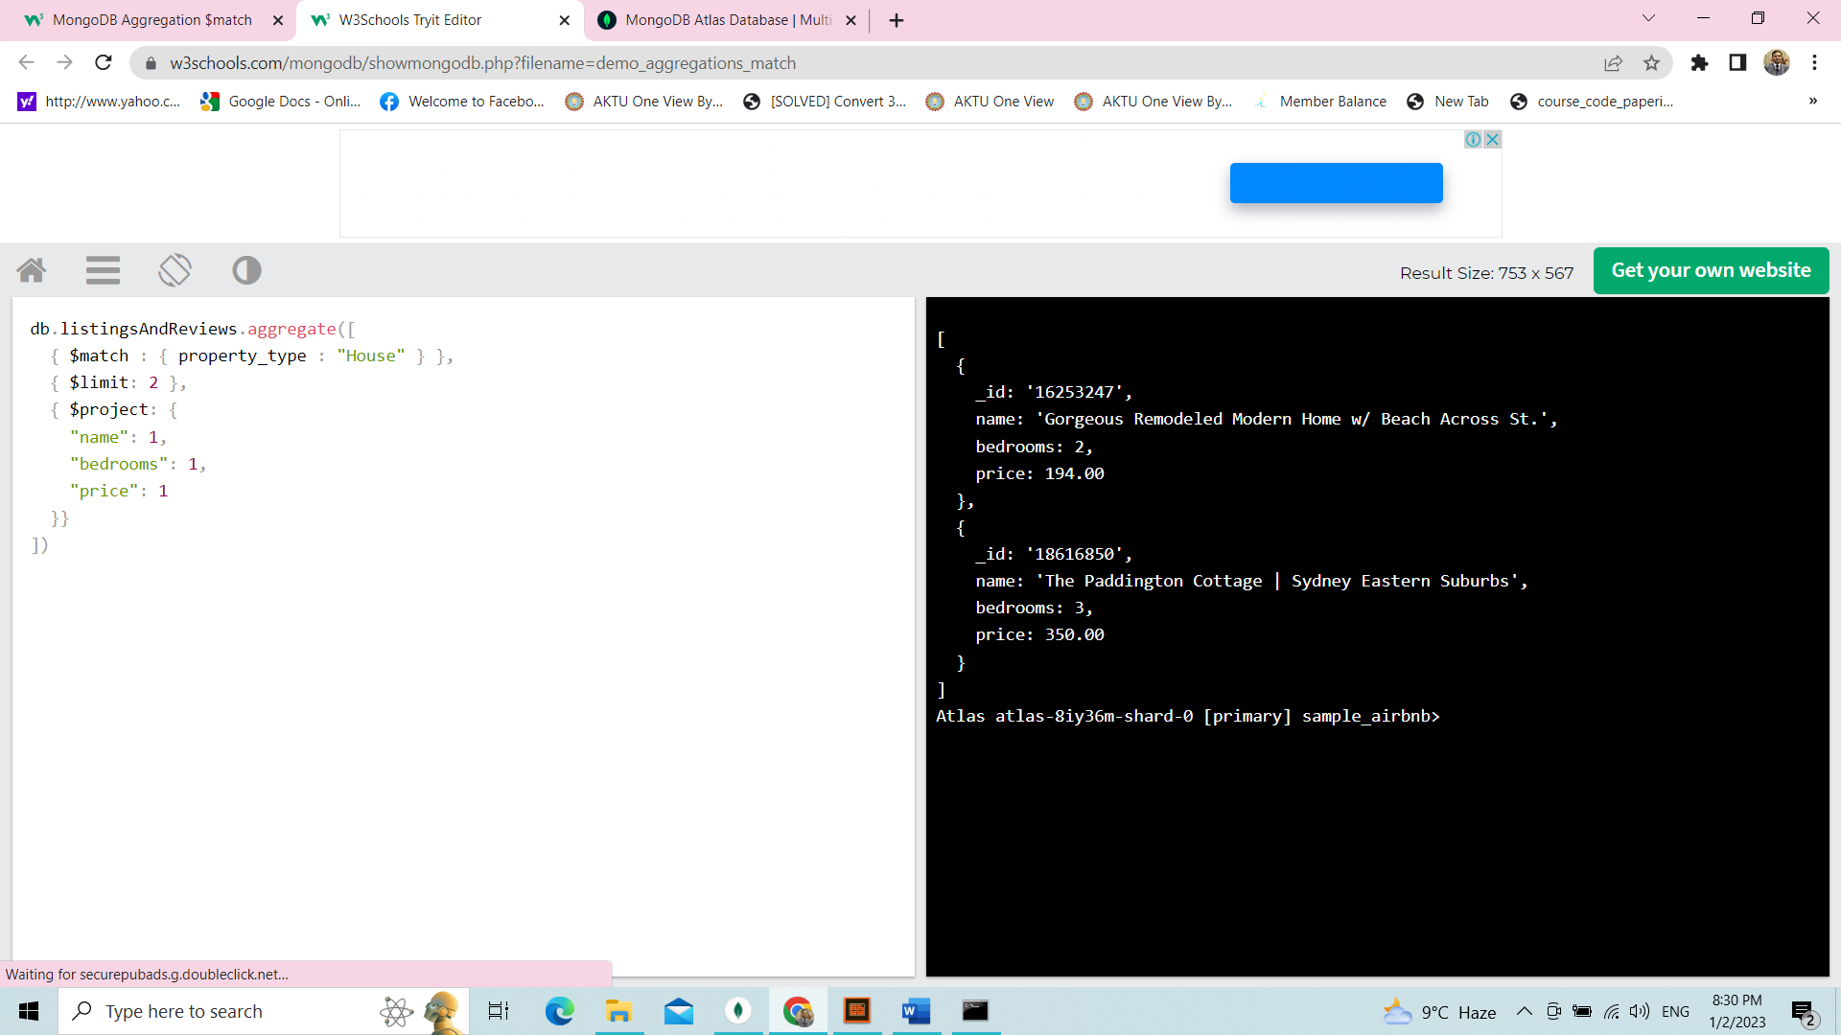

This will only return documents that have the property_type of "House".

# 

# MongoDB Aggregation $addFields

## Aggregation $addFields

This aggregation stage adds new fields to documents.

### Example

In this example, we are using the "sample_restaurants" database loaded from our sample data in the [Intro to Aggregations](https://www.w3schools.com/mongodb/mongodb_aggregations_intro.php) section.

db.restaurants.aggregate([

{

$addFields: {

avgGrade: { $avg: "$grades.score" }

}

},

{

$project: {

"name": 1,

"avgGrade": 1

}

},

{

$limit: 5

}

])

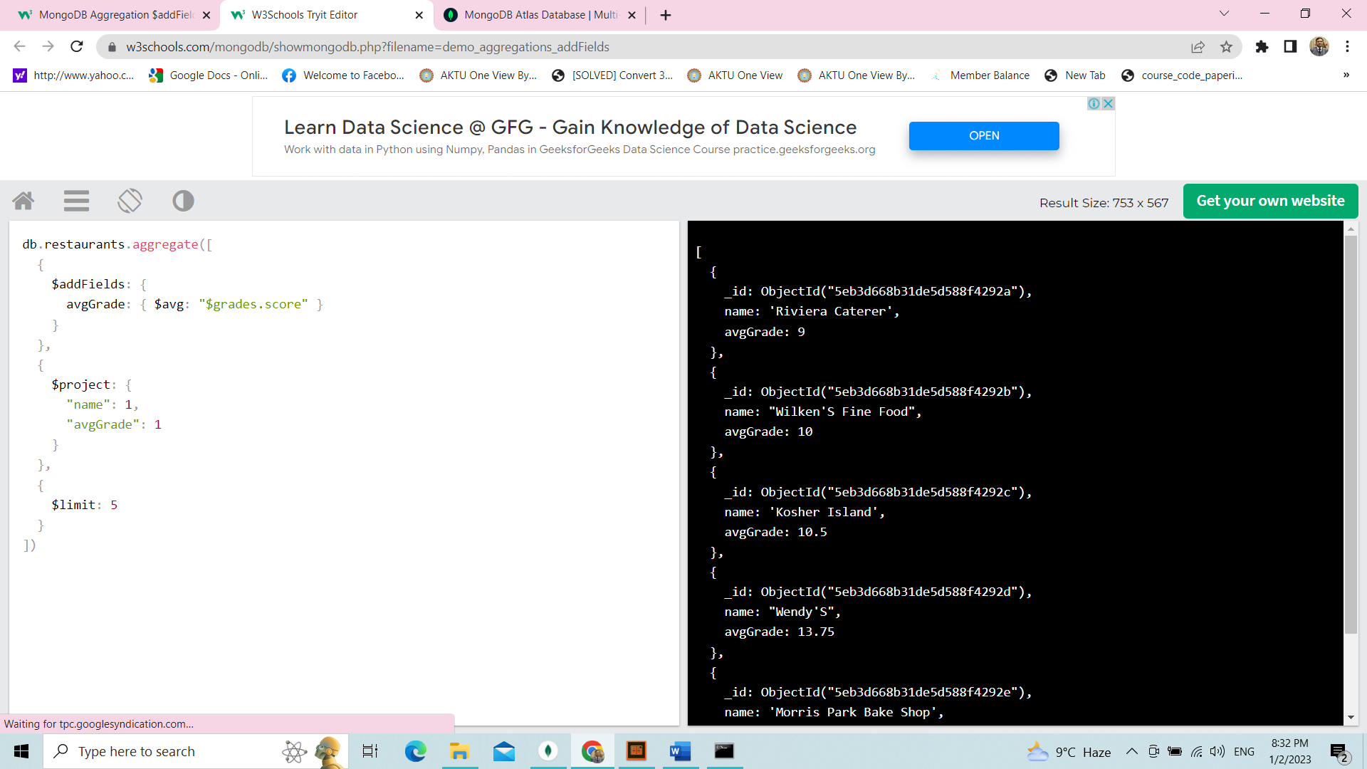

Add Fields to all record

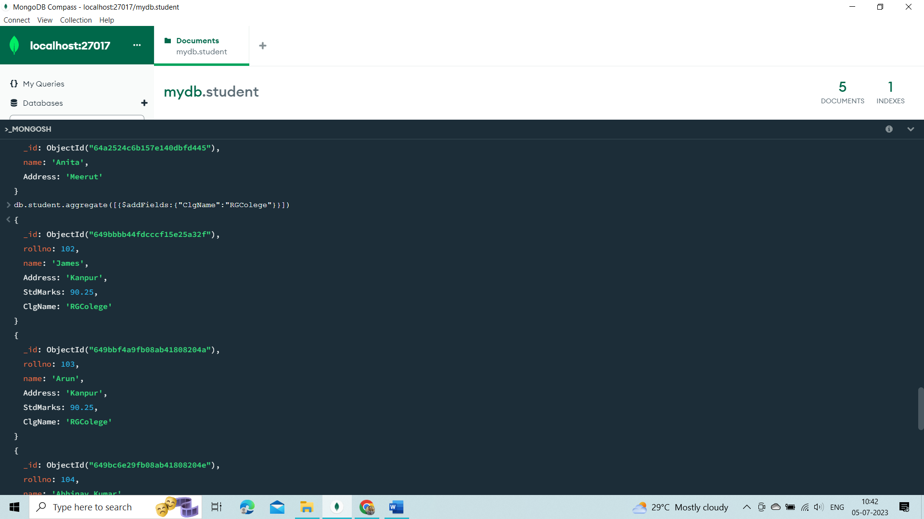

This will return the documents along with a new field, avgGrade, which will contain the average of each restaurants grades.score.

How to add Field to select record

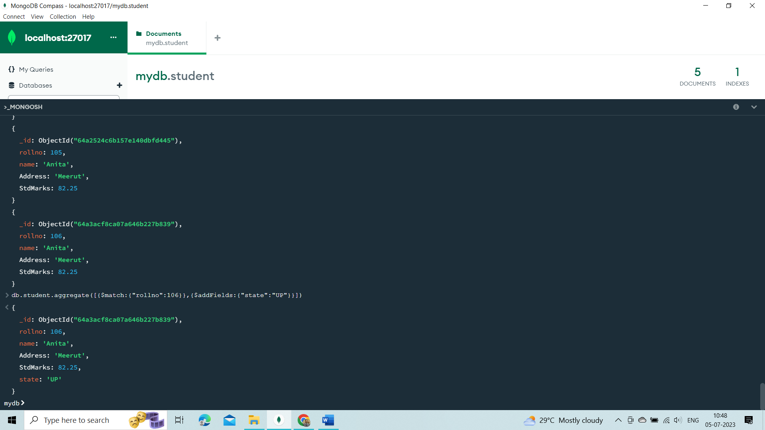

# MongoDB Aggregation $count

## Aggregation $count

This aggregation stage counts the total amount of documents passed from the previous stage.

### Example

In this example, we are using the "sample_restaurants" database loaded from our sample data in the [Intro to Aggregations](https://www.w3schools.com/mongodb/mongodb_aggregations_intro.php) section.

db.restaurants.aggregate([

{

$match: { "cuisine": "Chinese" }

},

{

$count: "totalChinese"

}

])

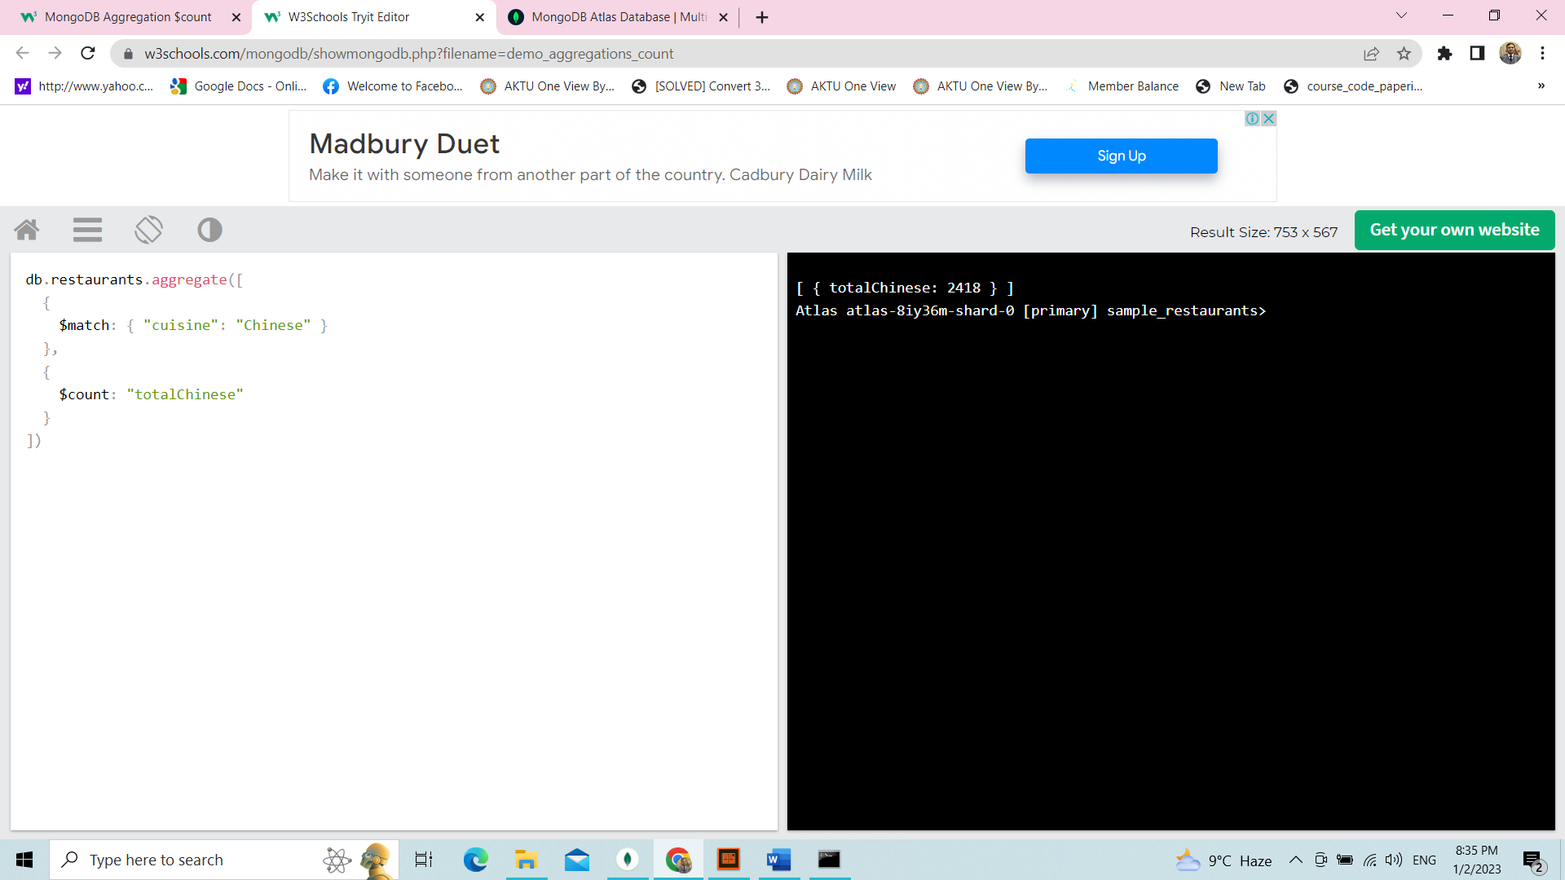

Counting

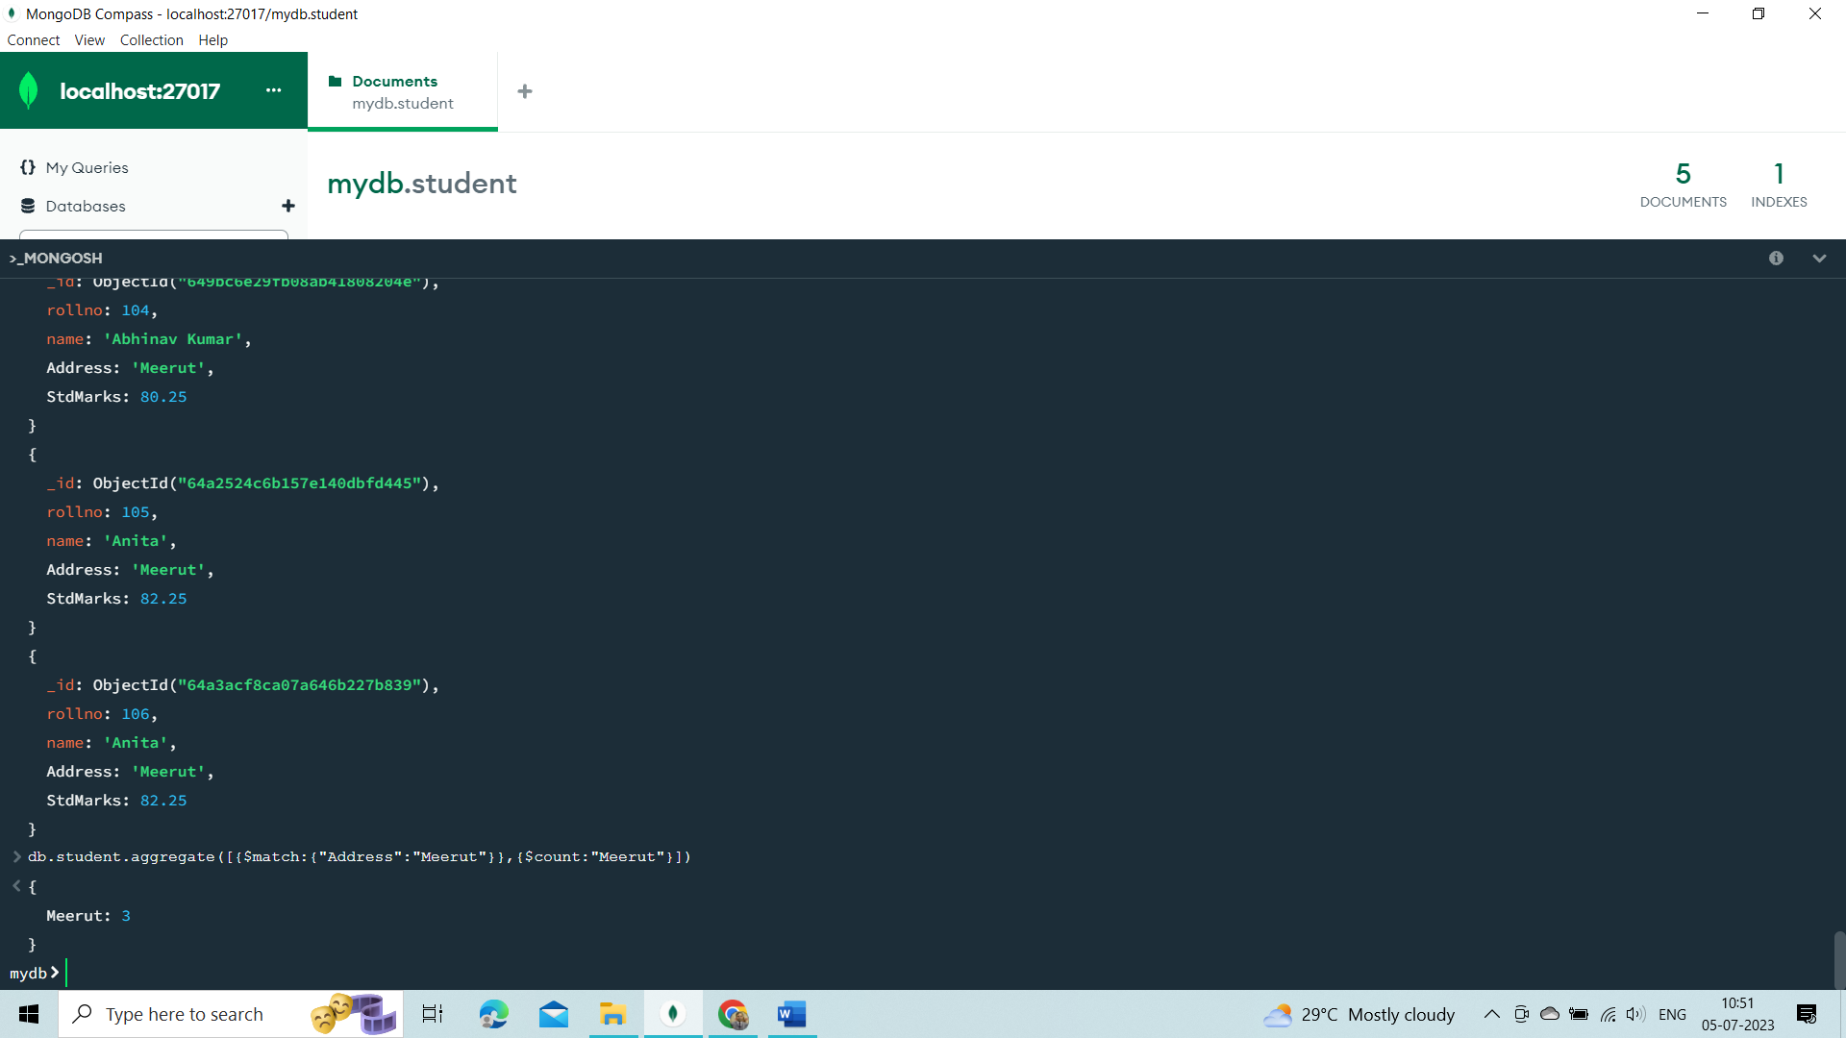––

This will return the number of documents at the $count stage as a field called "totalChinese".

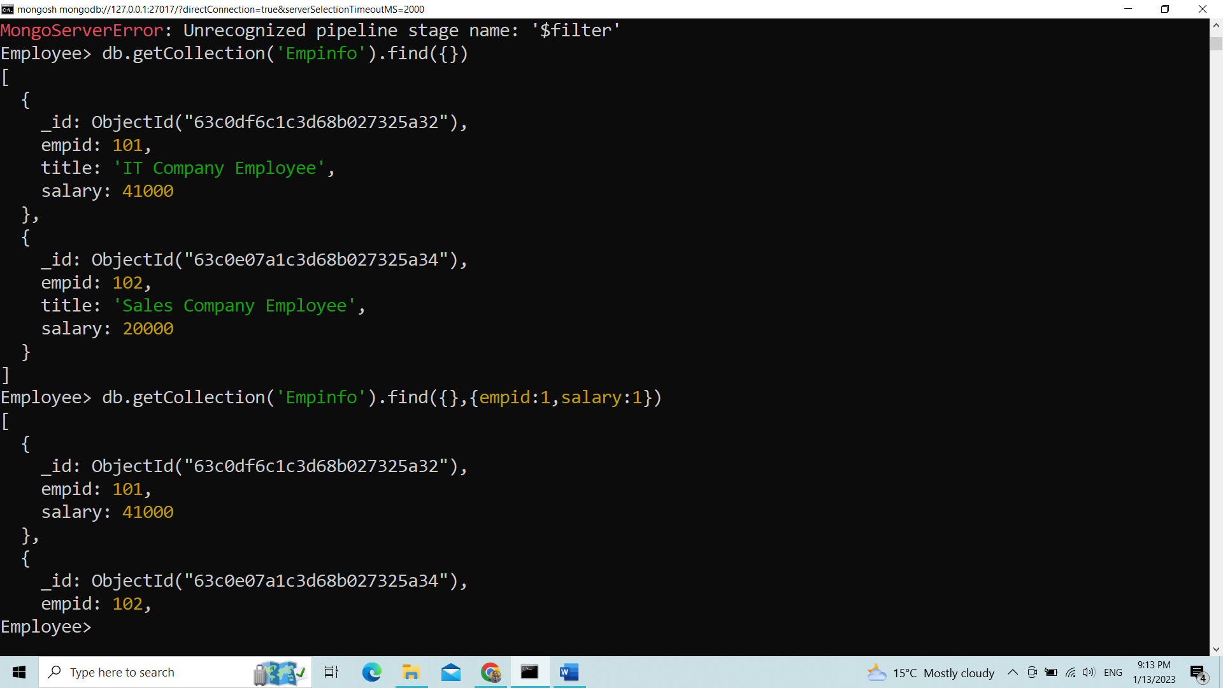

$filter Aggregation

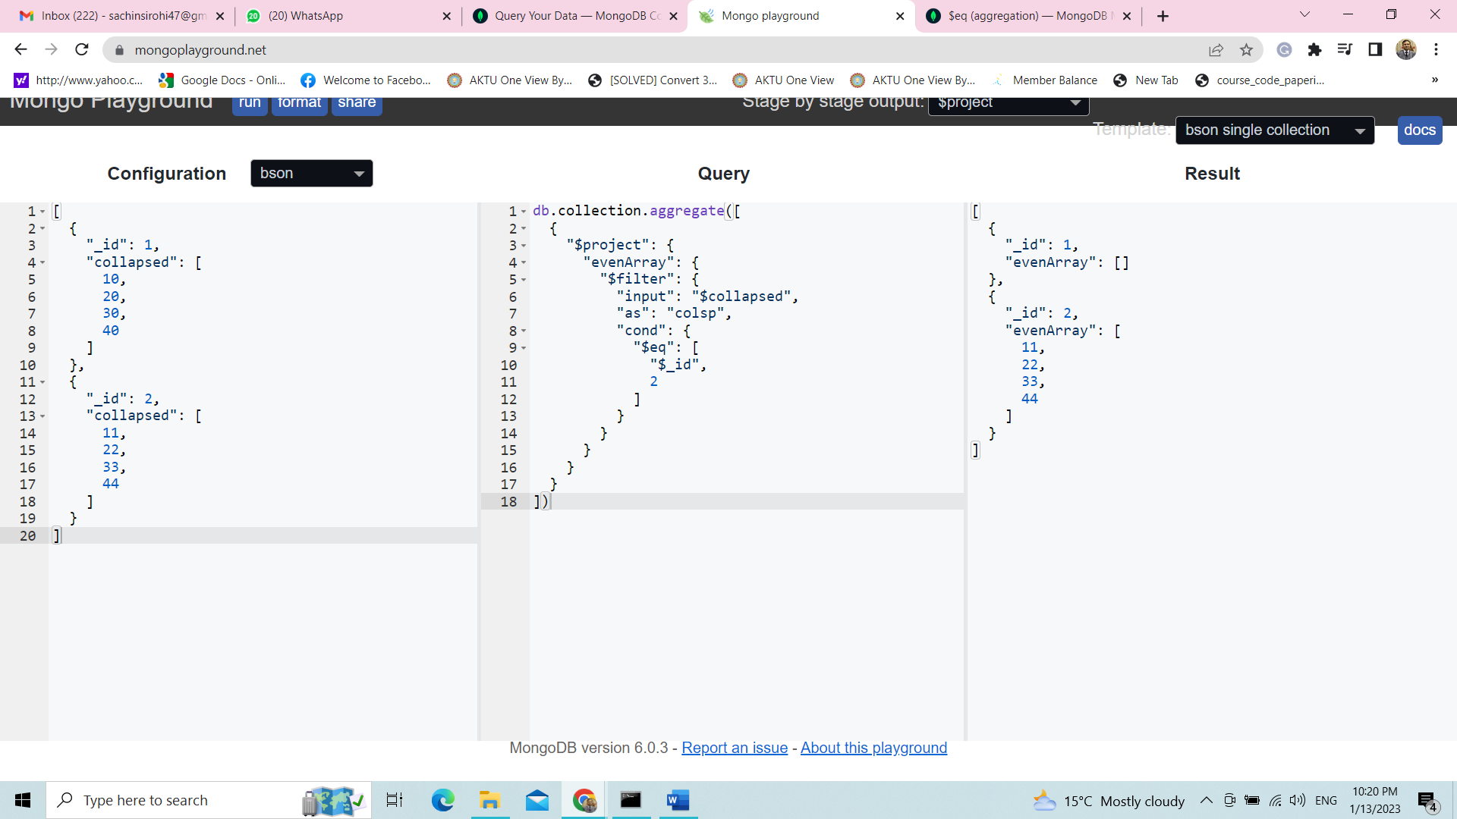

**Json Data (**name - collection)

[

{ "_id": 1,

"collapsed": [ 10, 20, 30, 40 ]

},

{ "_id": 2,

"collapsed": [ 11, 22, 33, 44 ] }

]

**Query**

db.collection.aggregate([

{

"$project": {

"evenArray": {

"$filter": {

"input": "$collapsed",

"as": "colsp",

"cond": {

"$eq": [ "$_id", 2 ]

} } } }

}

])

**Output**

[ {

"_id": 1,

"evenArray": []

},

{ "_id": 2,

"evenArray": [ 11, 22, 33, 44 ]

}

]

# Aggregation $lookup

This aggregation stage performs a left outer join to a collection in the same database.

There are four required fields:

* from: The collection to use for lookup in the same database
* localField: The field in the primary collection that can be used as a unique identifier in the from collection.
* foreignField: The field in the from collection that can be used as a unique identifier in the primary collection.
* as: The name of the new field that will contain the matching documents from the from collection.

**Lookup complete Exercise use for join**

**1) Create Student Collections**

db.students .insertMany([

{"id" : 1 , "pupil" : "John" , "std" : 6, "ht" : 153 , "wt" : 43},

{"id" : 2 , "pupil" : "Jack" , "std" : 6, "ht" : 164 , "wt" : 54},

])

**2) Create sport Collections**

db.sports .insertMany([

{"id" : 1, "sport" : "Basketball" , "winner" : "John"},

{"id" : 2, "sport" : "TT", "winner" : "Jack"},

{"id" : 3, "sport" : "Tennis" , "winner" : "John"},

])

The following query joins matches from sports collection to students collection based on the field value pupil and winner in students and sports respectively

**Using Lookup**

db.students.aggregate([

{

$lookup:

{

from : "sports",

localField : "pupil",

foreignField : "winner",

as : "games"

} } ] )

**Result**

{

_id: ObjectId(**"64aecda41a145337d63b1794"**),

id: 1,

pupil: **'John'**,

std: 6,

ht: 153,

wt: 43,

games: [

{

_id: ObjectId(**"64aece5d1a145337d63b1796"**),

id: 1,

sport: **'Basketball'**,

winner: **'John'**

},

{

_id: ObjectId(**"64aece5d1a145337d63b1798"**),

id: 3,

sport: **'Tennis'**,

winner: **'John'**

}

]

}

{

_id: ObjectId(**"64aecda41a145337d63b1795"**),

id: 2,

pupil: **'Jack'**,

std: 6,

ht: 164,

wt: 54,

games: [

{

_id: ObjectId(**"64aece5d1a145337d63b1797"**),

id: 2,

sport: **'TT'**,

winner: **'Jack'**

}

]

}

Using Limit

db.students.aggregate([

{

$lookup:

{

from : "sports",

localField : "pupil",

foreignField : "winner",

as : "games"

} },

{ $limit: 1

}])

**Match with project**

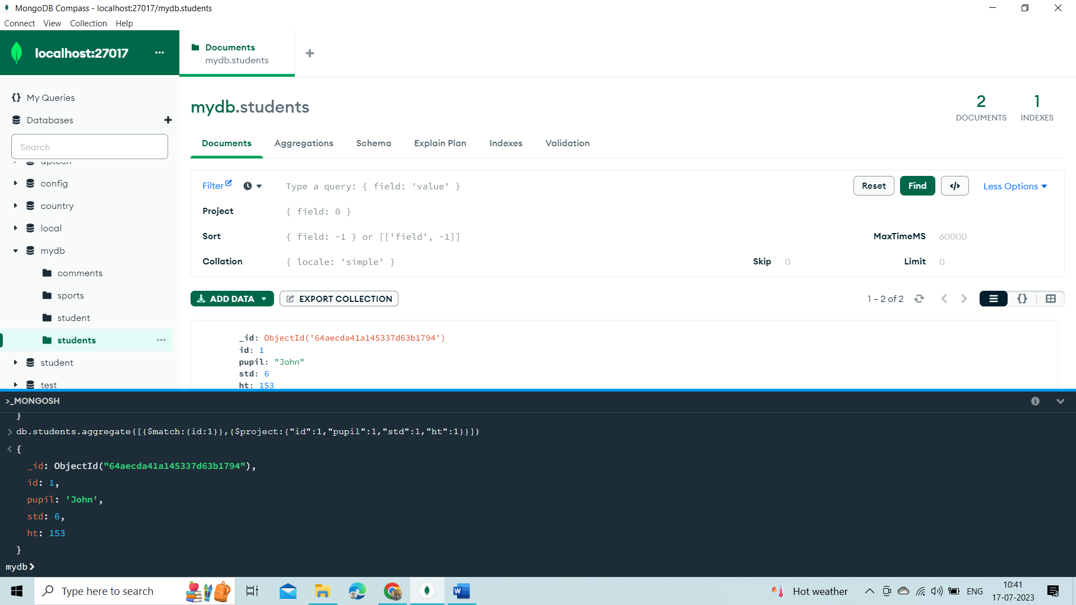

**Lookup with Limit and Project**

db.students.aggregate([

{

$lookup:

{

from : "sports",

localField : "pupil",

foreignField : "winner",

as : "games"

} },

{

$limit: 1

},

{

$project:

{"id":1,

"pupil":1,

"std":1,

"ht":1

}

}])

**Output**

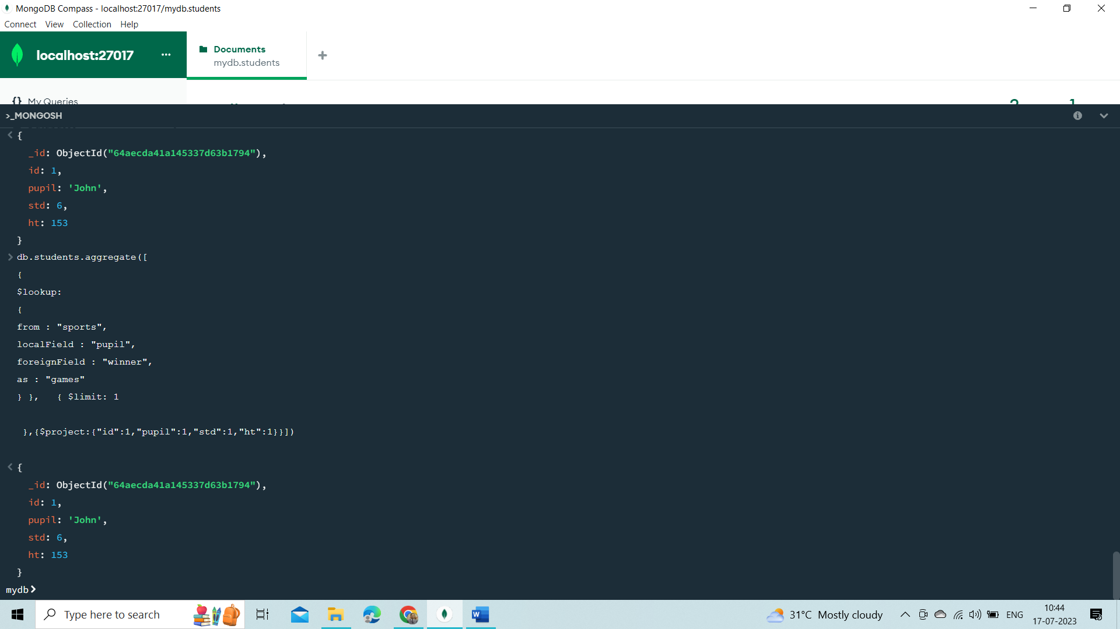

**Second Exercise**

Create two sample collections, inventory and orders:

db.inventory.insertMany( [

{ prodId: 100, price: 20, quantity: 125 },

{ prodId: 101, price: 10, quantity: 234 },

{ prodId: 102, price: 15, quantity: 432 },

{ prodId: 103, price: 17, quantity: 320 }

] )

db.orders.insertMany( [

{ orderId: 201, custid: 301, prodId: 100, numPurchased: 20 },

{ orderId: 202, custid: 302, prodId: 101, numPurchased: 10 },

{ orderId: 203, custid: 303, prodId: 102, numPurchased: 5 },

{ orderId: 204, custid: 303, prodId: 103, numPurchased: 15 },

{ orderId: 205, custid: 303, prodId: 103, numPurchased: 20 },

{ orderId: 206, custid: 302, prodId: 102, numPurchased: 1 },

{ orderId: 207, custid: 302, prodId: 101, numPurchased: 5 },

{ orderId: 208, custid: 301, prodId: 100, numPurchased: 10 },

{ orderId: 209, custid: 303, prodId: 103, numPurchased: 30 }

] )

db.createView( **"sales"**, **"orders"**, [

{

$lookup:

{

from: **"inventory"**,

localField: **"prodId"**,

foreignField: **"prodId"**,

as: **"inventoryDocs"**

}

},

{

$project:

{

_id: 0,

prodId: 1,

orderId: 1,

numPurchased: 1,

price: **"$inventoryDocs.price"**

}

},

{ $unwind: **"$price"** }

] )

### Example

In this example, we are using the "sample_mflix" database loaded from our sample data in the [Intro to Aggregations](https://www.w3schools.com/mongodb/mongodb_aggregations_intro.php) section.

db.comments.aggregate([

{

$lookup: {

from: "movies",

localField: "movie_id",

foreignField: "_id",

as: "movie_details",

},

},

{

$limit: 1

}

])

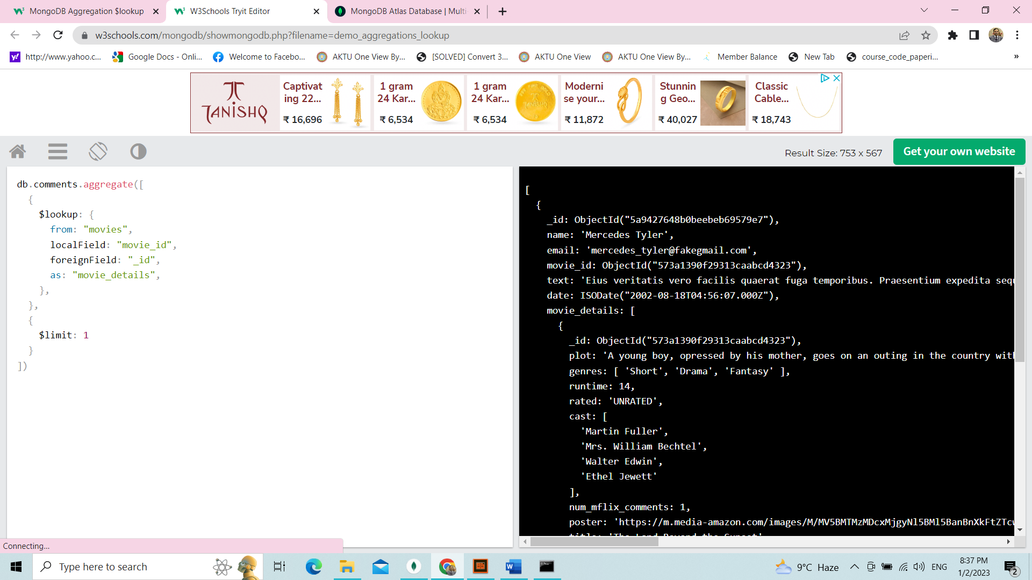

This will return the movie data along with each comment.

This is the full set of aggregation stages:

* $match – Filter documents
* $geoNear – Sort documents based on geographic proximity
* $project – Reshape documents (remove or rename keys or add new data based on calculations on the existing data)
* $lookup – Coming in 3.2 – Left-outer joins
* $unwind – Expand documents (for example create multiple documents where each contains one element from an array from the original document)
* $group – Summarize documents
* $sample – Randomly selects a subset of documents
* $sort – Order documents
* $skip – Jump over a number of documents
* $limit – Limit number of documents
* $redact – Restrict sensitive content from documents
* $out – *Coming in 3.2*\* – store the results in a new collection

# MongoDB Aggregation $out

## Aggregation $out

This aggregation stage writes the returned documents from the aggregation pipeline to a collection.

The $out stage must be the last stage of the aggregation pipeline.

### Example

In this example, we are using the "sample_airbnb" database loaded from our sample data in the [Intro to Aggregations](https://www.w3schools.com/mongodb/mongodb_aggregations_intro.php) section.

db.listingsAndReviews.aggregate([

{

$group: {

_id: "$property_type",

properties: {

$push: {

name: "$name",

accommodates: "$accommodates",

price: "$price",

},

},

},

},

{ $out: "properties_by_type" },

])

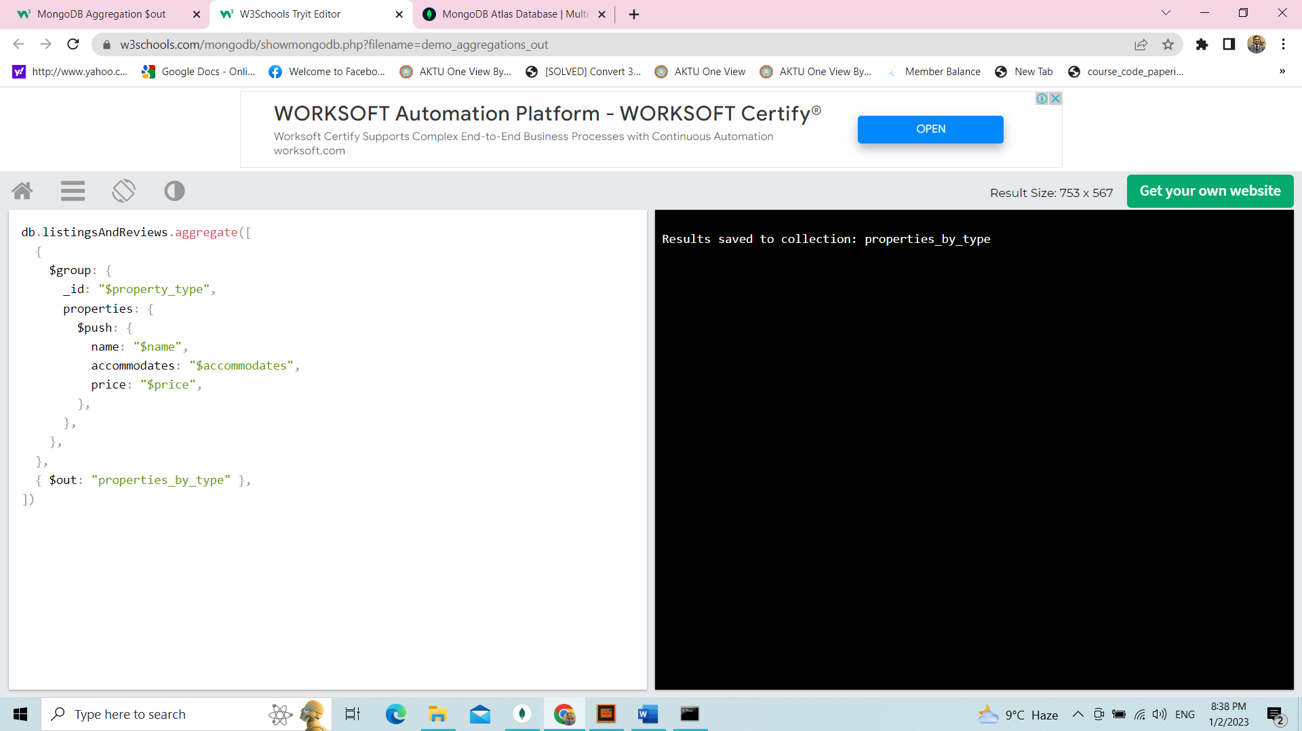

Save Result into out

db.students.aggregate([

{

$match:{id:1}

},

{

$project:{"id":1,"pupil":1,"std":1,"ht":1}

},

{

$out:"StudentResultOut"}

])

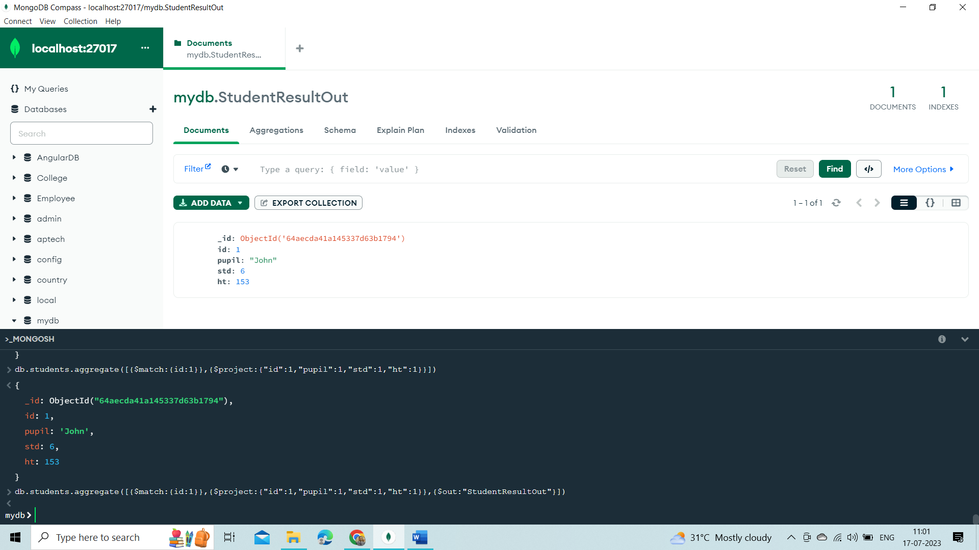

The first stage will group properties by the property_type and include the name, accommodates, and price fields for each. The $out stage will create a new collection called properties_by_type in the current database and write the resulting documents into that collection.

